<Development of a smart home control aplication>

project Management plan

Version *<1.0>*

<12//2024>

Student Name: Almir Bajrić

VERSION HISTORY

|  |  |  |  |  |  |
| --- | --- | --- | --- | --- | --- |
| Version # | Implemented  By | Revision  Date | Approved  By | Approval  Date | Reason |
| 1.0 | Almir Bajric | <mm/dd/yy> | <name> | <mm/dd/yy> | <reason> |
|  |  |  |  |  |  |
|  |  |  |  |  |  |
|  |  |  |  |  |  |

UP Template Version: 11/30/2022

**TABLE OF CONTENTS**

1 Introduction 3

1.1 Purpose of Project Management Plan 3

2 Executive Summary of Project Charter 5

2.1 Assumptions/Constraints 5

3 Scope Management 6

3.1 Product breakdown structure 6

3.2 Work breakdown structure 8

4 Schedule/Time Management 11

4.1 Milestones 11

4.2 Project Schedule and network diagrams 12

4.2.1 Structure of Activities and Predecessors 12

4.2.2 Time Completion 14

4.2.3 Network diagram 17

4.2.4 Dependencies 18

4.2.5 Critical Path Table 20

4.2.6 Critical Path Diagram 22

4.2.7 Project Deviation and Variance 24

4.3 GANT CHART 26

5 COST/BUDGET management 29

5.1 Resource Plan (Tables and Gant Chart) 30

5.2 Resource plan 33

5.3 Budget plan 35

5.4 Resource cost 37

5.5 Project crashing (Time Cost and Trade Offs) 39

5.6 Project crashing diagram 44

6 RISK managemenT 46

6.1 Risk log 48

6.2 Probability/Impact Matrix for Negative Risks 50

6.3 Probability/Impact Matrix for Positive Risks 53

7 REFERENCES 55

# Introduction

The **Development of a Smart Home Control Application** project is an innovative endeavor designed to address the increasing demand for connected and automated home environments. As IoT (Internet of Things) devices continue to proliferate and become integral to daily life, this project aims to create a centralized platform for users to seamlessly manage and control their smart home systems with ease and efficiency.

The Smart Home Control Application will bring together a variety of smart devices, such as lighting, thermostats, security cameras, appliances, and other IoT-enabled technologies, within a single, user-friendly interface. This integration will empower users to monitor, control, and automate their home environments, enhancing convenience, energy efficiency, and overall security.

The project places a strong emphasis on usability, prioritizing an intuitive design and seamless user experience. It will also focus on ensuring compatibility with a broad range of existing smart devices while retaining the adaptability to integrate emerging technologies. Additionally, the application will uphold stringent security and privacy measures, utilizing advanced encryption protocols to safeguard user data and interactions.

Aligned with the latest technological advancements and market trends, the project seeks to deliver a solution that addresses current consumer needs while anticipating future requirements. Through meticulous development, resource management, and adherence to deadlines, this project aspires to create a high-quality, reliable application that transforms the smart home experience for users globally.

## Purpose of Project Management Plan

The foundation for the successful execution and completion of the Development of a Smart Home Control Application project is the **Project Management Plan (PMP),** which offers a comprehensive and organised framework outlining the goals, procedures, and tactics required to accomplish the intended results. The PMP is intended to lead the project team through every stage of the project lifecycle, from initial planning to project closure, guaranteeing alignment with stakeholder expectations, organisational goals, and industry standards.

At its core, the PMP establishes the scope, schedule, budget, quality, risks, and resource management strategies for the project. By defining the project scope in detail, the PMP sets clear boundaries and prevents scope creep, ensuring all deliverables align with project objectives. This helps the team stay focused on priorities and deliver results effectively. The PMP also incorporates a schedule management plan, which outlines key milestones (**Table 1),** task dependencies, and deadlines. The schedule ensures that all activities are planned and tracked systematically, enabling timely delivery of each phase. Regular progress tracking, combined with contingency planning, helps mitigate risks and minimize delays.

An essential component of the PMP is the definition of roles and responsibilities for the project team and stakeholders. By clearly delineating authority levels and accountability, the PMP ensures effective collaboration and reduces the potential for confusion. The governance framework included in the plan provides escalation mechanisms for conflict resolution, change approvals, and critical decision-making, ensuring the project stays on course. Additionally, the PMP details the communication strategy, outlining how information will flow between team members, stakeholders, and sponsors. This includes defining communication tools, formats, and schedules to ensure that updates, progress reports, and stakeholder feedback are handled efficiently. Clear communication is critical to managing expectations, addressing challenges, and fostering stakeholder engagement.

The PMP also plays a vital role in risk management, identifying potential risks and uncertainties that may impact the project. These risks may include technical challenges, resource constraints, or external dependencies. The plan provides strategies for assessing and mitigating these risks, including contingency plans for handling unforeseen events. By proactively managing risks, the PMP ensures the project remains resilient and adaptable to changes in its environment. Risk monitoring and regular reporting keep the team aware of emerging risks and allow for early intervention, reducing the likelihood of significant disruptions.

Another key component of the PMP is budget and resource management. The PMP ensures that resources are allocated efficiently, expenditures are tracked, and the project remains within budgetary constraints. Mechanisms are also included for addressing budgetary risks and resource limitations, enabling the team to optimize resource utilization while maintaining financial control. This careful planning ensures that all project needs are met without unnecessary overspending. Furthermore, the PMP identifies resource dependencies and prioritizes critical allocations, ensuring smooth execution of tasks across the project lifecycle.

Quality management is an integral part of the PMP, ensuring that the Smart Home Control Application meets the highest standards of functionality, usability, and security. The plan defines quality benchmarks and incorporates review cycles to ensure deliverables meet or exceed stakeholder expectations. This focus on quality is critical for creating a product that is robust, reliable, and user-friendly. Testing strategies, quality assurance checklists, and feedback mechanisms are embedded in the PMP to ensure that the final product adheres to industry standards and satisfies end-user requirements. Additionally, the PMP ensures that quality management extends beyond product delivery, with ongoing monitoring and maintenance processes included for post-launch phases to maintain high standards.

As a living document, the PMP is reviewed and updated regularly to reflect changes in project requirements, timelines, or stakeholder needs. This adaptability ensures that the project remains aligned with its objectives while staying responsive to evolving challenges and opportunities. Regular updates allow the team to refine strategies and maintain focus on delivering a successful project. Additionally, lessons learned during the project are incorporated into the PMP, enhancing its effectiveness for future phases or similar projects. These updates also provide valuable insights to optimize resource allocation and improve processes, strengthening the project management framework for subsequent initiatives.

The Project Management Plan, or PMP, is essentially a planning tool and a control mechanism that guides the team and project manager through the entire project lifecycle. It offers a structured approach to managing all aspects of the project, from conceptualisation to deployment and post-launch support. The PMP ensures resource efficiency, timeline adherence, and alignment with organisational goals, allowing the team to deliver a high-quality product that meets stakeholder expectations. In addition to guaranteeing the success of this project, the PMP also establishes a solid precedent and reference point for managing future projects of comparable scale and complexity within the organisation. This thorough and proactive approach is crucial for the successful completion of the Smart Home Control Application project, guaranteeing its long-term value and sustainability. The PMP's clear structure and adaptability serve as the foundation for delivering an innovative solution that meets organisational priorities and user needs.

# Executive Summary of Project Charter

The Development of a Smart Home Control Application project is focused on building an advanced, user-friendly mobile and web application that empowers users to efficiently manage and control various smart devices within their homes through a single, centralized platform. This initiative addresses the rising demand for home automation, enabling users to monitor and operate devices like lighting, thermostats, security systems, and appliances directly from their smartphones or computers.

The primary goal of the project is to develop a secure, scalable, and intuitive smart home solution that integrates seamlessly with a diverse range of IoT (Internet of Things) devices. The application will support major platforms and function across multiple ecosystems, allowing users to create custom automation rules, control devices remotely, and receive real-time notifications for security and energy usage. By achieving this, the project aims to enhance convenience, optimize energy efficiency, and improve home security, all through an intuitive and accessible interface.

The Smart Home Control Application will follow a rigorous development process, incorporating extensive user feedback, thorough testing, and compliance with industry security standards. Leveraging best practices in software development and project management, the project aspires to deliver a high-quality product that meets user expectations and aligns with current market trends in the rapidly evolving home automation industry.

## Assumptions/Constraints

Assumptions:

1. **IoT Device APIs:** Most popular IoT devices will provide accessible, well-documented APIs for integration.
2. **Compatible Devices:** Users are assumed to own compatible smart devices, such as lights, thermostats, and security cameras.
3. **Stable Internet:** Reliable internet connectivity is expected for remote control and device synchronization.
4. **Cloud Scalability:** Cloud services (e.g., AWS, Azure) will handle user data, device control, and real-time updates effectively.
5. **Regulatory Compliance:** The project assumes adherence to legal and industry standards (e.g., GDPR) for privacy and data security.

**Constraints:**

1. **Device Compatibility:** Integration may be limited by older or proprietary IoT devices with restricted API access.
2. **Timeframe:** The project must be completed within 9–12 months, with delays potentially impacting delivery.
3. **Budget:** A limited budget may restrict features, device integration, or hiring additional developers.
4. **Security:** Implementing strict security measures requires resources for compliance, testing, and audits.
5. **Expertise:** Limited availability of skilled personnel in IoT, mobile/web development, and cloud management may cause delays or require outsourcing.

# Scope Management

The Scope Management Plan outlines how the scope of the Smart Home Control Application project will be defined, validated, and controlled. Effective scope management ensures that the project delivers its required deliverables, remains focused on the agreed objectives, and avoids scope creep. This plan defines the processes for managing the project scope from initiation to completion, ensuring alignment with stakeholder expectations and preventing unnecessary changes.

At the project’s start, the scope will be clearly defined to include the development of a mobile and web application for managing smart devices, IoT device integration (lighting, security, appliances), cloud-based data storage for real-time synchronization, and robust security features, including authentication and data encryption. The application will also offer customization for automation rules and schedules. The scope will outline exclusions, such as not supporting certain legacy devices in the initial release, which will be considered in future updates.

Throughout the project, scope validation will ensure deliverables meet agreed-upon requirements. Regular stakeholder reviews and User Acceptance Testing (UAT) will confirm that the application meets end-users' needs, while performance testing will ensure reliable operation. Once deliverables are approved, the project manager will document validation and obtain stakeholder sign-off.

Scope control ensures the project stays within defined boundaries. Any changes to scope will undergo a formal change request process, with an impact analysis on timeline, budget, and resources. A Change Control Board (CCB) will review and approve changes, which will only be incorporated if approved. The project will use a scope baseline, which includes the approved scope statement, Work Breakdown Structure (WBS) (**Figure** **2**), and deliverables, serving as a reference point for monitoring changes and ensuring the project aligns with its original objectives.Regular scope reporting will track progress and deviations, with variance analysis comparing planned versus actual performance. A change log will document any approved changes and their impact on the project.

Tools like the WBS will break the project into manageable components, ensuring all tasks are covered. The scope statement will detail deliverables, exclusions, and assumptions, and the scope baseline will guide all scope-related decisions. This comprehensive scope management plan ensures the Smart Home Control Application project stays on track, delivering on time, within budget, and meeting stakeholder expectations, while providing flexibility to manage necessary changes.

## Product breakdown structure

The **Figure 1 PBS Structure** for the Smart Home Control Application outlines the key components and subcomponents essential for the system’s development. This hierarchical framework categorizes the system into core functionalities, including the user interface, device management, automation engine, cloud integration, security, and testing. Each section is further subdivided into specific tasks and features, ensuring every aspect of the application is comprehensively addressed. By mapping out these components, the PBS serves as a foundational tool to clarify the project’s scope and structure, ensuring no critical element is overlooked during development.

Beyond its structural organization, the PBS plays a vital role in project management by guiding resource allocation and development planning. It highlights the relationships between various system components, identifying potential dependencies and bottlenecks early in the process. This proactive approach allows for a well-structured workflow, aligning the team’s efforts to minimize risks and optimize resource utilization. Additionally, the PBS provides a clear roadmap for project timelines, enabling the team to track progress efficiently and maintain alignment with project objectives.

Moreover, the PBS fosters effective communication with stakeholders by visually representing the system’s complexity and scope. Its hierarchical format simplifies the explanation of technical details, making it accessible to non-technical audiences. This clarity strengthens stakeholder engagement and ensures that their requirements are consistently reflected in the development process. Ultimately, the PBS not only aids in organizing and managing the project but also promotes collaboration and transparency, which are critical to delivering a successful Smart Home Control Application.

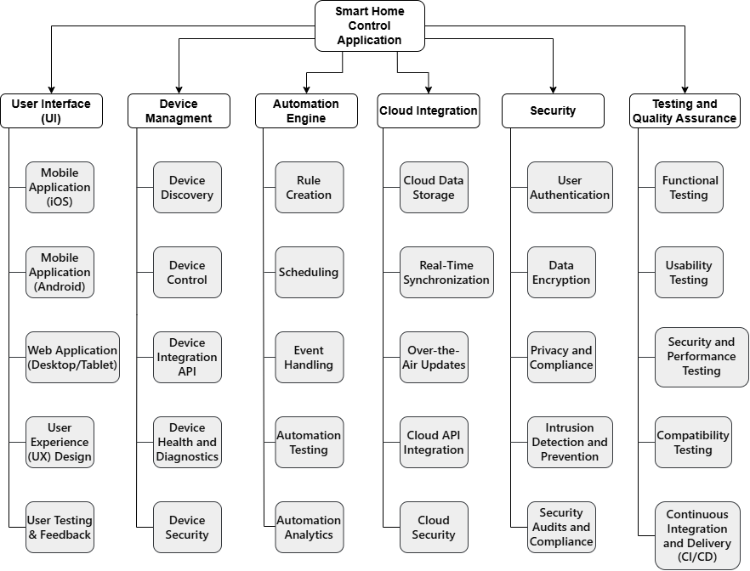

Figure 1 PBS Structure

The **Figure 1 PBS Structure** for the Smart Home Control Application outlines the key components necessary for developing an intuitive and reliable application. This hierarchical framework categorizes the project into critical elements such as the user interface, device management, automation engine, cloud integration, and security. Each component is broken down into specific tasks, ensuring every aspect of the system’s development is meticulously planned and executed. This structure not only provides a clear roadmap for resource allocation and task distribution but also ensures that all deliverables align with stakeholder expectations.

A significant aspect of the PBS is its focus on ensuring the application meets user needs effectively. The user interface, designed for mobile and web platforms, facilitates seamless user interactions, while device management enables users to control IoT devices effortlessly. The automation engine adds value by allowing users to create personalized schedules and rules for their smart homes. Cloud integration ensures synchronization and scalability, while stringent security measures protect user data and system integrity. Together, these elements make the application functional, secure, and adaptable for future expansions.

Additionally, the PBS serves as a vital communication tool, offering stakeholders a visual representation of the project’s scope and complexity. This clarity fosters collaboration, enabling the team to identify dependencies, optimize workflows, and minimize risks. By organizing the project into manageable components, the PBS ensures systematic progress, aligns efforts with objectives, and lays a robust foundation for delivering a high-quality smart home solution that meets current and future demands.

## Work breakdown structure

The **Figure 2 WBS Structure** for the Smart Home Control Application project provides a detailed and organized breakdown of tasks and deliverables essential for achieving project objectives efficiently and effectively. It divides the project into manageable components, ensuring clear responsibility allocation, progress tracking, and alignment with stakeholder expectations and project goals. By segmenting tasks systematically, the WBS allows for better clarity in understanding the scope of the project, ensuring that all stakeholders are aware of their roles and deliverables at each phase.

The WBS outlines key deliverables, including mobile and web application development, IoT device integration, cloud synchronization, and the implementation of robust security features to ensure system reliability and performance. Each deliverable is further broken down into tasks such as user interface design, device management protocol implementation, automation engine development, and data encryption to meet compliance and security standards. Furthermore, the WBS provides a framework for integrating user feedback and iterative improvements, ensuring the final product meets user expectations and industry benchmarks. By addressing potential technical and operational challenges proactively, the WBS aligns all tasks with strategic project goals and timelines.

By defining tasks and dependencies clearly, the WBS ensures comprehensive coverage of the project, enabling effective progress monitoring, resource allocation, and early identification of potential risks. Its structured approach helps the project remain on schedule, within budget, and aligned with its goals. The WBS also supports performance tracking and reporting, providing transparency and accountability across the team and stakeholders. This fosters effective communication, collaboration, and trust, ensuring successful project execution while delivering value to end users. Moreover, it simplifies complexity by breaking down large objectives into smaller, manageable parts, helping teams maintain focus and productivity throughout the project lifecycle.

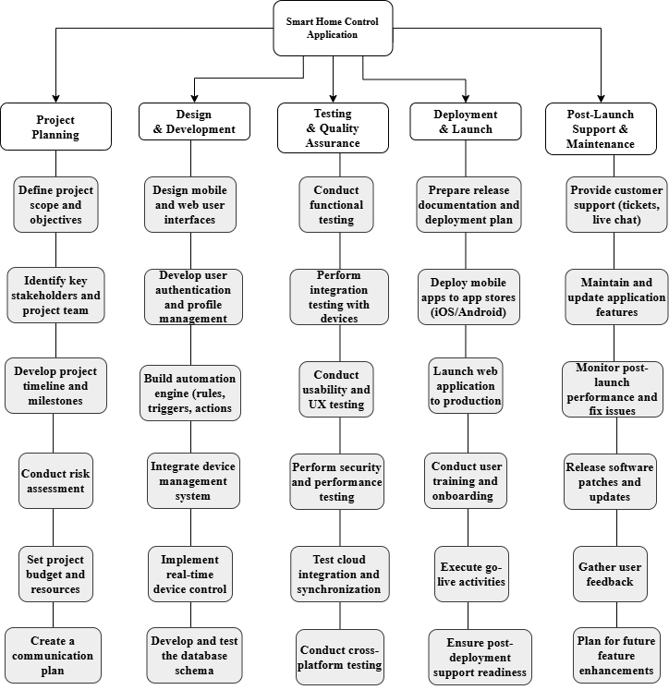

Figure 2 WBS Structure

The **Figure 2 WBS Structure** for the Smart Home Control Application is a comprehensive framework that divides the project into well-defined and manageable components. This structure ensures that all tasks are clearly organized, responsibilities are allocated effectively, and deliverables are tracked to completion. It breaks the project into five main phases, each containing six subcategories that represent critical tasks to be accomplished for effective project execution.

The Project Planning phase establishes the foundational framework for the Smart Home Control Application. It involves defining the project’s scope, objectives, and deliverables, identifying key stakeholders, and assembling the project team. Additional tasks include developing a comprehensive timeline with milestones, assessing potential risks, and formulating mitigation strategies. A detailed communication plan is also created to ensure consistent updates and alignment among all stakeholders. Budget and resource requirements are determined, ensuring the project has adequate support to proceed. Effective planning aligns the project with its goals, ensures timelines are realistic, and sets the stage for efficient execution.

The Design & Development phase is where the application’s core features are created. This includes designing intuitive user interfaces for both mobile and web platforms, focusing on usability and accessibility. A secure user authentication system is implemented, incorporating features like password protection and biometric access. The automation engine is developed to support creating and managing rules, triggers, and actions. The device management system is integrated, allowing users to connect, monitor, and control IoT devices. Additional development tasks include enabling real-time device control functionality and designing and testing a robust database schema. The success of this phase ensures a user-friendly, functional, and versatile application capable of managing various smart devices seamlessly.

During the Testing & Quality Assurance phase, the application is rigorously tested to ensure it meets high standards for functionality, performance, and security. Functional testing validates the application’s features against requirements, while integration testing ensures compatibility with IoT devices. Usability testing evaluates the interface for intuitiveness and ease of use across diverse user groups. Cross-platform testing confirms seamless operation across different devices and operating systems. Security testing protects against vulnerabilities, and performance testing ensures reliability under typical and peak usage conditions. This phase is critical for identifying and resolving issues, ensuring the application is deployment-ready and meets stakeholder expectations.

The Deployment & Launch phase is focused on delivering the application to end users. Preparation tasks include developing release documentation, finalizing deployment plans, and performing pre-launch validations. Mobile apps are deployed to iOS and Android app stores, while the web application is launched into a live production environment. User training and onboarding sessions help users understand and navigate the application’s features effectively. Final go-live activities involve validating system functionality and ensuring all components work cohesively. Monitoring systems and support channels are established to address any immediate post-launch issues. This phase ensures the application is launched smoothly and users are supported during the transition.

The Post-Launch Support & Maintenance phase ensures the application remains functional, secure, and adaptable over time. Customer support is provided through multiple channels, including ticketing systems and live chat, to address user queries and issues. Regular updates and patches are released to improve functionality and resolve bugs. User feedback is gathered systematically to identify areas for improvement and inform future feature development. Continuous performance monitoring ensures the application operates reliably, while regular security audits safeguard user data and maintain system integrity. This phase ensures long-term success by keeping the application aligned with evolving user needs and technological advancements.

The **Figure 2 WBS Structure** organizes the Smart Home Control Application project into these clearly defined phases, detailing every task and deliverable necessary for success. This hierarchical structure facilitates efficient tracking of progress, effective resource allocation, and timely identification of potential challenges. By breaking the project into manageable components and aligning them with specific goals and milestones, the WBS ensures that the project remains on schedule, within budget, and aligned with stakeholder expectations. It serves as a critical tool for managing complexity and delivering a high-quality product.

# Schedule/Time Management

The milestones outlined in Table 1 represent critical checkpoints in the development and delivery of the Smart Home Control Application. These milestones ensure that key project deliverables are completed on schedule and align with the overall project goals. They are designed to provide clear targets for the project team, facilitate progress tracking, and allow for timely identification and resolution of potential risks or delays. Each milestone corresponds to a significant phase of the project, ensuring that all essential aspects of development, integration, and testing are covered.

The first milestone, Completion of User Interface (UI) Design, focuses on finalizing the application’s visual and functional design. This phase ensures that the application provides an intuitive and user-friendly interface for mobile and web platforms, catering to users of diverse technical backgrounds. Once this milestone is achieved, the foundation for subsequent development activities is firmly established, enabling seamless implementation of core functionalities such as device management and automation.

The final milestones, Device Management Integration Complete and Testing Completion, mark the successful realization of critical features and quality assurance. These phases ensure the application’s ability to integrate and control IoT devices effectively while undergoing rigorous testing to meet high standards of functionality, security, and reliability. By reaching these milestones, the project demonstrates readiness for deployment and sets the stage for delivering a robust, user-focused smart home solution that meets stakeholder expectations and industry benchmarks.

## Milestones

**Table 1 Milestones** provides a detailed timeline for the critical phases in the development and delivery of the Smart Home Control Application. These milestones mark significant achievements in the project, serving as checkpoints that ensure the team remains on schedule and aligned with project objectives. By outlining the expected completion times for each milestone, the table provides clarity on the project timeline, enabling efficient resource allocation, task prioritization, and progress tracking. The structured layout ensures that all team members and stakeholders are aware of the key phases of development, promoting accountability and collaboration.

Each milestone corresponds to a pivotal phase in the project lifecycle. The Completion of User Interface (UI) Design sets the foundation for the application's usability and aesthetics, while Device Management Integration Complete ensures core functionalities are operational. The Testing Completion milestone marks the culmination of rigorous quality assurance processes, guaranteeing the application’s readiness for deployment. Together, these milestones provide a roadmap for project execution, allowing for the identification and mitigation of potential risks, ensuring the timely delivery of a reliable and user-friendly smart home application.

|  |  |
| --- | --- |
| **Milestones** | **Estimated Completion Time** |
| Completion of User Interface (UI) Design | Four weeks after kickoff. |
| Device Management Integration Complete | Fifteen weeks after kickoff. |
| Testing Completion | Forty weeks after kickoff |

Table 1 Milestones

The milestones outlined in **Table 1** represent critical phases in the development of the Smart Home Control Application, ensuring the project progresses systematically and meets its objectives. The first milestone, Completion of User Interface (UI) Design, focuses on creating a user-friendly, intuitive, and visually appealing interface for both mobile and web platforms. This phase is pivotal as it establishes the foundation of the application’s usability, ensuring that users of varying technical expertise can navigate and interact seamlessly. The successful completion of this milestone allows the team to proceed confidently with subsequent development tasks, ensuring alignment with the overall project goals.

The second milestone, Device Management Integration Complete, ensures the application’s core functionality of connecting and controlling IoT devices is fully realized. This phase includes the implementation of features such as automatic device discovery, real-time controls, and protocol compatibility. By achieving this milestone, the application demonstrates its ability to support diverse IoT ecosystems, providing users with seamless and reliable device management capabilities. This milestone also signifies the transition from development to comprehensive integration and testing of interconnected systems.

The final milestone, Testing Completion, represents the culmination of quality assurance activities, including functional, security, and usability testing. This phase validates the application’s performance under various conditions, ensuring it meets industry standards and user expectations. Rigorous testing guarantees the system is robust, secure, and ready for deployment. Achieving this milestone not only confirms the application’s readiness but also sets the stage for a successful launch, providing stakeholders with a high-quality, user-focused smart home solution.

## Project Schedule and network diagrams

The Schedule Management Plan for the Smart Home Control Application ensures that all project activities are completed within the designated timeframe, adhering to the milestones outlined in **Table 1**. It provides a structured approach to managing tasks, dependencies, and resources throughout the project lifecycle. By establishing a baseline schedule, the project team gains a clear reference point to track progress and manage changes effectively, ensuring that the project stays aligned with its objectives and stakeholder expectations.

The schedule is developed using tools such as Gantt charts and network diagrams, which visually represent task durations, dependencies, and the critical path. These tools highlight key milestones, including Completion of User Interface (UI) Design (Week 4), Device Management Integration Complete (Week 15), and Testing Completion (Week 40). These milestones serve as checkpoints, ensuring that significant deliverables are completed on time and that the project progresses systematically. The visualization of tasks and dependencies supports efficient resource allocation and facilitates proactive risk management.

To maintain schedule integrity, weekly progress reviews are conducted to compare actual performance against the baseline. This regular monitoring enables the team to identify potential delays and implement corrective actions promptly. For any significant deviations, a formal change control process is followed, allowing for proper adjustments and re-baselining as needed. Tools such as Microsoft Project and Trello are employed to streamline task tracking, monitor dependencies, and maintain alignment with deadlines. This proactive and structured approach ensures the project remains on track, meets critical milestones, and fulfills its objectives within the defined timeline.

### Structure of Activities and Predecessors

The **Structure of Activities and Predecessors** presented in **Table 2** serves as a critical component of the schedule management for the Smart Home Control Application project. This table provides a hierarchical breakdown of the tasks required to deliver the project successfully, ensuring that activities are logically sequenced and aligned with project objectives. By clearly outlining task dependencies and their relationships, the structure supports efficient resource allocation and minimizes risks of delays. Each task is associated with specific predecessors, ensuring a logical flow of work and seamless transitions between project phases.

The table organizes project tasks into five main phases: Project Planning, Design & Development, Testing & Quality Assurance, Deployment & Launch, and Post-Launch Support & Maintenance. Each phase comprises a series of interconnected activities, with earlier tasks forming the foundation for subsequent work. For instance, the planning phase focuses on establishing the project’s scope, timeline, and resource requirements, which are essential for guiding the design and development of the application. Similarly, activities such as risk assessment and communication planning ensure that the team is well-prepared to address challenges and maintain stakeholder alignment.

By defining task sequences and dependencies, **Table 2** facilitates the creation of network diagrams and Gantt charts, which are vital tools for tracking progress and managing project schedules. This structured approach ensures all tasks contribute effectively to project milestones, reducing inefficiencies and enhancing productivity. Moreover, it provides transparency for stakeholders, enabling clear communication and collaboration throughout the project lifecycle. The Structure of Activities and Predecessors is an essential framework that underpins the successful delivery of a robust and user-focused smart home application.

|  |  |  |
| --- | --- | --- |
| **Activity no.** | **Activity name** | **Predeccesors** |
| 1.1 | **Define project scope and objectives** | NONE |
| 1.2 | **Identify key stakeholders and project team** | 1.1 |
| 1.3 | **Develop project timeline and milestones** | 1.1 |
| 1.4 | **Conduct risk assessment** | 1.3 |
| 1.5 | **Set project budget and resources** | 1.2, 1.3, 1.4 |
| 1.6 | **Create a communication plan** | 1.5 |
| 2.1 | **Design mobile and web user interfaces** | 1.6 |
| 2.2 | **Develop user authentication and profile management** | 2.1 |
| 2.3 | **Build automation engine (rules, triggers, actions** | 2.2 |
| 2.4 | **Integrate device management system** | 2.3 |
| 2.5 | **Implement real-time device control** | 2.4 |
| 2.6 | **Develop and test the database schema** | 2.3 |
| 3.1 | **Conduct functional testing** | 2.5, 2.6 |
| 3.2 | **Perform integration testing with devices** | 3.1 |
| 3.3 | **Conduct usability and UX testing** | 3.2 |
| 3.4 | **Perform security and performance testing** | 3.3 |
| 3.5 | **Test cloud integration and synchronization** | 3.4 |
| 3.6 | **Conduct cross-platform testing** | 3.5 |
| 4.1 | **Prepare release documentation and deployment plan** | 3.6 |
| 4.2 | **Deploy mobile apps to app stores(iOS/Android)** | 4.1 |
| 4.3 | **Launch web application to production** | 4.1 |
| 4.4 | **Conduct user training and onboarding** | 4.2, 4.3 |
| 4.5 | **Execute go-live activities** | 4.4 |
| 4.6 | **Ensure post-deployment support readiness** | 4.5 |
| 5.1 | **Provide customer support (tickets, live chat)** | 4.6 |
| 5.2 | **Maintain and update application features** | 5.1 |
| 5.3 | **Monitor post-launch performance and fix issues** | 5.2 |
| 5.4 | **Release software patches and updates** | 5.3 |
| 5.5 | **Gather user feedback** | 5.1 |
| 5.6 | **Plan for future feature enhancements** | 5.4, 5.5 |

Table 2 Structure of Activities and Predecessors

**Structure of Activities and Predecessors (Table 2)** for the Smart Home Control Application organizes 30 tasks into five main phases: Project Planning, Design & Development, Testing & Quality Assurance, Deployment & Launch, and Post-Launch Support & Maintenance. Each activity is sequenced logically based on the **WBS Structure** and is connected to its predecessors, ensuring proper alignment with the project timeline and smooth task transitions.

In the planning phase, foundational tasks such as defining the scope and identifying stakeholders establish the groundwork for subsequent phases. These activities flow into Design & Development, where user interfaces are created, automation systems are built, and device management is integrated. Testing & Quality Assurance rigorously evaluates performance, usability, and security before transitioning into Deployment & Launch, where the application is released, and user training is conducted. Finally, the Post-Launch phase focuses on monitoring, updates, and feedback collection.

This structured approach eliminates dead paths, ensures all tasks contribute to the project objectives, and supports resource allocation, progress tracking, and the creation of network diagrams for effective schedule management. By linking tasks logically and ensuring alignment with the project timeline, this framework enables the team to address dependencies efficiently, mitigate risks, and maintain steady progress. The integration of visual tools like Gantt charts enhances clarity and communication among team members and stakeholders, ensuring that the project proceeds smoothly through each phase to achieve its objectives.

### Time Completion

**Table 3 Time Completion** outlines the duration of each activity required for the successful delivery of the Smart Home Control Application. It provides a detailed timeline, ensuring all tasks are planned and executed efficiently to meet project deadlines. The Program Evaluation and Review Technique (PERT) is used to estimate the time required for each task, offering a structured approach that considers variability and uncertainties. By incorporating estimates that account for different scenarios, the PERT method enables the project team to create a balanced and realistic project timeline, ensuring tasks are completed within the designated timeframe.

The Program Evaluation and Review Technique (PERT) is used to estimate the time required for each task based on three parameters:

* **a (Optimistic Time):** The shortest possible time to complete the task under ideal conditions.
* **m (Most Likely Time):** The time most commonly required to complete the task under normal conditions.
* **b (Pessimistic Time):** The longest possible time if significant delays occur.

The Expected Time (TE) for each task is calculated using the formula:

Where:

**a** - Optimistic time

**m** - Most likely time

**b** - Pessimistic time

**TE** - Expected time

The **Variance (σ²)**, which measures the uncertainty in time estimates, is calculated using:

Where:

* **a**: Optimistic time
* **b**: Pessimistic time
* **variance** : Variability in the estimated time

|  |  |  |  |  |  |  |
| --- | --- | --- | --- | --- | --- | --- |
| **Activity no.** | **Predeccesors** | **Duration (TE)** | **a** | **b** | **m** | **Variance (** |
| 1.1 | NONE | 3 days | 2 | 3 | 5 | 0.25 |
| 1.2 | 1.1 | 2 days | 1 | 2 | 4 | 0.25 |
| 1.3 | 1.1 | 4 days | 3 | 4 | 6 | 0.25 |
| 1.4 | 1.3 | 3 days | 2 | 3 | 5 | 0.25 |
| 1.5 | 1.2, 1.3 | 5 days | 3 | 5 | 8 | 0.69 |
| 1.6 | 1.5 | 2 days | 1 | 2 | 4 | 0.25 |
| 2.1 | 1.6 | 6 days | 5 | 6 | 9 | 0.44 |
| 2.2 | 2.1 | 6 days | 4 | 6 | 10 | 1.0 |
| 2.3 | 2.2 | 8 days | 6 | 8 | 12 | 1.0 |
| 2.4 | 2.3 | 5 days | 3 | 5 | 7 | 0.44 |
| 2.5 | 2.4 | 3 days | 2 | 3 | 6 | 0.44 |
| 2.6 | 2.3 | 5 days | 4 | 5 | 7 | 0.25 |
| 3.1 | 2.5, 2.6 | 7 days | 5 | 7 | 10 | 0.69 |
| 3.2 | 3.1 | 5 days | 4 | 5 | 8 | 0.69 |
| 3.3 | 3.2 | 4 days | 2 | 4 | 6 | 0.44 |
| 3.4 | 3.2 | 6 days | 4 | 6 | 9 | 0.69 |
| 3.5 | 3.4 | 7 days | 5 | 7 | 10 | 0.69 |
| 3.6 | 3.5 | 8 days | 6 | 8 | 11 | 0.69 |
| 4.1 | 3.6 | 5 days | 3 | 5 | 8 | 0.69 |
| 4.2 | 4.1 | 4 days | 2 | 4 | 7 | 0.69 |
| 4.3 | 4.1 | 3 days | 2 | 3 | 6 | 0.44 |
| 4.4 | 4.2, 4.3 | 6 days | 4 | 6 | 10 | 1.0 |
| 4.5 | 4.4 | 5 days | 3 | 5 | 8 | 0.69 |
| 4.6 | 4.5 | 3 days | 2 | 3 | 5 | 0.25 |
| 5.1 | 4.6 | 6 days | 4 | 6 | 9 | 0.69 |
| 5.2 | 5.1 | 5 days | 3 | 5 | 7 | 0.44 |
| 5.3 | 5.2 | 7 days | 5 | 7 | 10 | 0.69 |
| 5.4 | 5.3 | 8 days | 6 | 8 | 11 | 0.69 |
| 5.5 | 5.1 | 6 days | 4 | 6 | 9 | 0.69 |
| 5.6 | 5.4, 5.5 | 5 days | 3 | 5 | 7 | 0.44 |

Table 3 Time Completion

**Table 3 Time Completion** for the Development of a Smart Home Control Application ensures accurate estimation and scheduling of all project activities. Using the Program Evaluation and Review Technique (PERT), the plan incorporates uncertainty into project timelines by providing optimistic, most likely, and pessimistic time estimates for each of the 30 activities. These estimates are used to calculate the expected time (TE) and variance for each task, offering a clear understanding of potential time deviations and risks. This structured approach enables the team to create a realistic timeline, ensuring the project progresses smoothly and aligns with established milestones.

The activities are sequenced based on their dependencies, ensuring tasks are completed in the correct order and that critical phases are prioritized. For example, foundational tasks like defining the project scope and identifying stakeholders set the stage for subsequent activities, such as designing user interfaces, developing automation systems, and integrating device management. Critical tasks, including building the automation engine and conducting functional testing, are timed accurately to align with project milestones, ensuring the project maintains its momentum and adheres to deadlines.

Most activities demonstrate low variance, indicating a high degree of certainty in their time estimates. Straightforward tasks like creating communication plans or conducting cross-platform testing are predictable, whereas more complex activities, such as defining the project budget or deploying mobile apps to app stores, involve higher variance due to external dependencies or technical complexity. By monitoring these high-variance tasks closely, the team can mitigate potential delays. This detailed planning ensures an intuitive user interface, seamless automation features, and reliable security and cloud integrations, keeping the project on track to meet both its technical goals and stakeholder expectations within the designated timeframe.

### Network diagram

The "Development of a Smart Home Control Application" project's activities, dependencies, and logical sequences are all represented in detail in the **Figure 3 Network diagram** below. The Activity on Node (AON) diagram is an essential tool for comprehending the flow of tasks from the start of the project to its conclusion. Each node represents an activity, and the connecting arrows show dependencies and precedence relationships, guaranteeing a clear depiction of how tasks are interconnected.

The diagram highlights the critical path, which represents the sequence of activities that directly influence the project’s completion time. Identifying the critical path is essential for effective time management, as it allows the project team to focus resources on tasks that could cause delays if not completed on schedule. Additionally, the diagram showcases non-critical tasks, enabling the team to identify areas where scheduling flexibility exists. This comprehensive overview helps in optimizing workflows, allocating resources efficiently, and mitigating potential risks by visualizing bottlenecks or overlaps. By providing a structured layout of activities and their relationships, the network diagram ensures better coordination, tracking, and control throughout the project lifecycle, aligning efforts to meet the project’s objectives within the defined time and budget constraints.

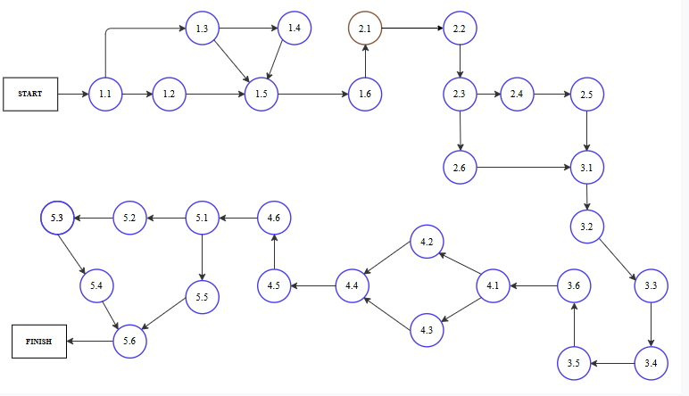Figure 3 Network diagram

For the "Development of a Smart Home Control Application" project, the network diagram above, which was created using **Table 2**, offers a thorough visual depiction of the activities and their dependencies. The Activity on Node (AON) diagram successfully lays out the logical flow of tasks, with each node standing for a distinct activity and the arrows showing the sequence and dependency relationships between them. The diagram captures the structure described in **Table 2**, guaranteeing alignment between planned activities and their execution.

The critical route, or the order of tasks that directly affects the project's total duration, is highlighted in the diagram. The project team can concentrate their efforts on tasks that need to be finished on schedule in order to prevent delays in the project's delivery by identifying these crucial jobs. The picture also highlights non-essential tasks, providing scheduling and resource allocation flexibility that can assist balance workloads and reduce risks.

This network diagram is a vital tool for project planning and management, providing a clear and concise overview of the project's workflow. It helps ensure all tasks are executed in the correct sequence, dependencies are respected, and potential bottlenecks or delays are proactively addressed. By providing a structured visualization of the project’s activities, it enhances coordination, monitoring, and control, allowing the project team to stay aligned with objectives, timelines, and resource constraints throughout the project lifecycle. This alignment ensures that all tasks contribute effectively to the completion of the project's deliverables. Moreover, the diagram aids in better communication among stakeholders by presenting a straightforward and universally understandable project roadmap. The diagram also serves as a foundation for performance evaluation, enabling the project team to track progress, identify delays, and implement corrective actions in real time to ensure the successful completion of the project.

### Dependencies

Dependencies in the Development of a Smart Home Control Application project are critical for ensuring the smooth execution of tasks and maintaining the logical sequence of activities. Dependencies indicate relationships between tasks, where the start or finish of one activity influences another. Proper identification and management of these dependencies allow for efficient resource allocation, risk mitigation, and timely delivery of the project. The dependencies in this project are categorized into **internal** and **external** dependencies.

**Internal dependencies**

Internal dependencies are those within the project’s control, managed entirely by the project team. These dependencies define the flow of tasks and ensure proper sequencing for efficient execution. Managing internal dependencies is vital for aligning activities with the project timeline and avoiding bottlenecks.

* **Design Completion Dependencies:** The development of mobile and web user interfaces (Activity 2.1) must be completed before progressing to user authentication and profile management (Activity 2.2), as the design serves as the foundation for secure and user-friendly functionality.
* **Automation System Dependencies**: Building the automation engine (Activity 2.3) requires the prior development of user authentication (Activity 2.2). Similarly, integrating the device management system (Activity 2.4) depends on the automation engine’s completion.
* **Testing Dependencies**: Functional testing (Activity 3.1) must be completed before beginning integration testing with devices (Activity 3.2) and usability testing (Activity 3.3). These tests ensure the system’s foundational functionality before more advanced testing.
* **Deployment Dependencies**: Preparing release documentation and deployment plans (Activity 4.1) is necessary before deploying mobile apps to app stores (Activity 4.2) and launching the web application to production (Activity 4.3).
* **Post-Launch Support Dependencies**: Ensuring post-deployment support readiness (Activity 4.6) is dependent on completing all go-live activities (Activity 4.5), including user training and onboarding.

**External Dependencies**

External dependencies involve factors outside the direct control of the project team, such as third-party approvals, external systems, or environmental factors. These dependencies can introduce uncertainties and risks, requiring careful monitoring and contingency planning.

* **Third-Party Approval Dependencies:** The deployment of mobile apps to app stores (Activity 4.2) relies on external approvals from platforms like the Apple App Store and Google Play Store. Delays in these approvals can impact the project timeline.
* **Cloud Service Dependencies**: Cloud synchronization testing (Activity 3.5) is dependent on the availability and stability of external cloud services, such as AWS or Azure, to ensure real-time data updates and secure storage.
* **Regulatory and Compliance Dependencies**: Compliance with industry standards, such as GDPR or IoT security protocols, affects secure device pairing, authentication testing, and data encryption implementation (Activity 3.4). External audits or certifications may be required.
* **User Feedback Dependencies:** Gathering user feedback (Activity 5.5) depends on the active participation of end-users and external communication channels. Delays in user responses may impact the timely planning of future feature enhancements.

The project team will utilize Gantt charts and a **Figure 3 Network diagram** as primary tools for managing and visualizing task dependencies. These tools provide a structured and detailed representation of task sequences, durations, and interdependencies, ensuring effective project scheduling and progress tracking. The Gantt chart offers a high-level timeline view that simplifies monitoring and communication with stakeholders. Meanwhile, the network diagram provides a more detailed representation of task relationships and logical flows, as outlined in **Table 2.** Together, these tools enable the team to identify critical paths, prioritize key tasks, and allocate resources effectively to ensure timely project delivery.

The network diagram is particularly useful for illustrating how tasks are interconnected and identifying the critical path—the sequence of activities that directly impacts the overall project timeline. This insight allows the team to focus on high-priority tasks while also recognizing non-critical tasks that offer scheduling flexibility. Regular updates to the Gantt chart incorporate findings from the network diagram, helping to adjust timelines and manage dependencies proactively. By combining these tools with regular dependency reviews, the project team ensures that workflows are optimized, risks are mitigated, and progress is maintained. This integrated approach guarantees a well-coordinated effort that adheres to the project schedule and achieves the successful delivery of the Smart Home Control Application.

To manage both internal and external dependencies effectively, the team will establish clear processes and communication channels. Internal dependencies, such as the sequence from functional testing (Activity 3.1) to integration and usability testing (Activities 3.2 and 3.3), will be closely monitored using the network diagram to ensure tasks are executed in the correct order. External dependencies, like obtaining approvals for app store deployment or integrating with cloud services, will be addressed through regular status updates and collaboration with third-party stakeholders. Documenting and tracking these dependencies will minimize risks associated with delays and miscommunications, ensuring the project maintains momentum. This proactive approach ensures all dependencies are aligned with the project’s evolving needs and objectives, supporting seamless transitions between phases.

### Critical Path Table

**Figure 4 Critical Path Node Legend** serves as a comprehensive visual guide for our project, effectively capturing the intricate dependencies among various activities while emphasizing the critical path that ultimately dictates the project’s overall timeline. This methodical approach involves detailed calculations of critical scheduling elements such as Early Start (ES), Early Finish (EF), Late Start (LS), Late Finish (LF), and slack time for each activity. By performing these calculations, we have successfully identified key activities that must be completed on schedule to avoid potential delays in the overall project completion.

This visual representation offers a clear and structured view of the project’s sequential flow, enabling team members and stakeholders to better understand the project's progression, critical dependencies, and potential risks. It highlights the sequence of tasks that form the critical path—activities that, if delayed, would directly affect the project’s final delivery date. Moreover, it facilitates proactive decision-making by drawing attention to tasks with zero slack, ensuring that resources are allocated efficiently and potential bottlenecks are addressed in advance.

By interpreting this diagram, project managers can enhance planning accuracy, anticipate potential delays, and maintain a balanced approach to project execution. The Critical Path Node Legend (Figure 4) provides an essential key to decode the numerical information presented within the nodes, helping readers to interpret important data such as start and finish times, slack values, and dependencies. Following the legend, **Figure 5 Critical Path Diagram** offers a detailed visual representation of the project’s critical path.

EF

ES

No.

LS

LF

Figure 4 Critical Path Node Legend

**Early Start (ES):** ES indicates the earliest time an activity can begin, considering the dependencies and constraints within the project network. It defines the initial point at which an activity can be started based on the completion of its preceding tasks. ES plays a key role in determining the forward schedule of the project, ensuring that tasks are initiated as early as possible to maintain project momentum.

**Early Finish (EF):** EF signifies the earliest point in time an activity can be completed. It is derived by adding the duration of the activity to its Early Start. This parameter is essential for understanding the project’s timeline and predicting when an activity will conclude, assuming there are no delays. EF helps project managers plan subsequent tasks and assess progress in real-time.

**Late Start (LS):** LS specifies the latest time an activity can begin without causing a delay in the overall project completion. It is calculated during the backward pass of the project scheduling process and is instrumental in determining slack or float for each activity. Knowing the LS helps project managers prioritize tasks and allocate resources efficiently, ensuring critical activities are started on time.

**Late Finish (LF):** LF represents the latest time an activity can be finished without jeopardizing the project's final deadline. It is computed by adding the duration to the LS. Together, LS and LF help project managers assess the project’s flexibility and identify tasks that are on the critical path, where no delays can be afforded. Understanding these parameters ensures timely project completion and resource optimization.

The critical path method (CPM) is a key technique in project management that helps determine the longest sequence of activities required to complete a project. It provides a clear understanding of the tasks that directly impact the project’s final deadline. By identifying these critical tasks, the project manager can focus on the most important activities, ensuring that delays in these tasks are avoided to keep the project on track.

In the Development of a Smart Home Control Application, the critical path consists of various interconnected tasks, including the design and development of the user interface, IoT device integration, cloud synchronization, and the implementation of security features. Each of these activities is critical because they form the foundation of the smart home application, and delays in any of these areas will result in a delay in the entire project’s delivery. The dependencies between these tasks make it crucial to identify which activities lie on the critical path to allocate resources accordingly and mitigate potential risks.

The critical path analysis is not only useful for time management but also helps optimize resource utilization by highlighting tasks that can be executed concurrently or expedited. Additionally, it aids in proactive decision-making by enabling the project manager to apply schedule compression techniques, such as crashing or fast-tracking, to reduce overall project duration if needed. In the following section, a detailed critical path table will be presented, outlining the key tasks, their durations, dependencies, and slack times.

|  |  |  |  |  |  |  |  |  |
| --- | --- | --- | --- | --- | --- | --- | --- | --- |
| **Activity No.** | **Predecessors** | **Duration (TE)** | **Early Start (ES)** | **Early Finish (EF)** | **Late Start (LS)** | **Late Finish (LF)** | **Slack (SL)** | **Critical Path (CP)** |
| 1.1 | NONE | 3 | 0 | 3 | 0 | 3 | 0 | Yes |
| 1.2 | 1.1 | 2 | 3 | 5 | 4 | 6 | 1 | No |
| 1.3 | 1.1 | 4 | 3 | 7 | 3 | 7 | 0 | Yes |
| 1.4 | 1.3 | 3 | 7 | 10 | 7 | 10 | 0 | Yes |
| 1.5 | 1.2, 1.3, 1.4 | 5 | 5 | 10 | 5 | 10 | 0 | Yes |
| 1.6 | 1.5 | 2 | 10 | 12 | 10 | 12 | 0 | Yes |
| 2.1 | 1.6 | 6 | 12 | 18 | 12 | 18 | 0 | Yes |
| 2.2 | 2.1 | 6 | 18 | 24 | 18 | 24 | 0 | Yes |
| 2.3 | 2.2 | 8 | 24 | 32 | 24 | 32 | 0 | Yes |
| 2.4 | 2.3 | 5 | 32 | 37 | 32 | 37 | 0 | Yes |
| 2.5 | 2.4 | 3 | 37 | 40 | 37 | 40 | 0 | Yes |
| 2.6 | 2.3 | 5 | 32 | 37 | 37 | 42 | 5 | No |
| 3.1 | 2.5, 2.6 | 7 | 40 | 47 | 40 | 47 | 0 | Yes |
| 3.2 | 3.1 | 5 | 47 | 52 | 47 | 52 | 0 | Yes |
| 3.3 | 3.2 | 4 | 52 | 56 | 52 | 56 | 0 | Yes |
| 3.4 | 3.2 | 6 | 52 | 58 | 52 | 58 | 0 | Yes |
| 3.5 | 3.4 | 7 | 58 | 65 | 58 | 65 | 0 | Yes |
| 3.6 | 3.5 | 8 | 65 | 73 | 65 | 73 | 0 | Yes |
| 4.1 | 3.6 | 5 | 73 | 78 | 73 | 78 | 0 | Yes |
| 4.2 | 4.1 | 4 | 78 | 82 | 78 | 82 | 0 | Yes |
| 4.3 | 4.1 | 3 | 82 | 85 | 85 | 88 | 3 | No |
| 4.4 | 4.2, 4.3 | 6 | 82 | 88 | 82 | 88 | 0 | Yes |
| 4.5 | 4.4 | 5 | 88 | 93 | 88 | 93 | 0 | Yes |
| 4.6 | 4.5 | 3 | 93 | 96 | 93 | 96 | 0 | Yes |
| 5.1 | 4.6 | 6 | 96 | 102 | 96 | 102 | 0 | Yes |
| 5.2 | 5.1 | 5 | 102 | 107 | 102 | 107 | 0 | Yes |
| 5.3 | 5.2 | 7 | 107 | 114 | 107 | 114 | 0 | Yes |
| 5.4 | 5.3 | 8 | 114 | 122 | 114 | 122 | 0 | Yes |
| 5.5 | 5.1 | 6 | 102 | 108 | 108 | 114 | 6 | No |
| 5.6 | 5.4, 5.5 | 5 | 122 | 127 | 122 | 127 | 0 | Yes |

Table 4 Critical Path Table

**Critical Path Table** represents the sequence of tasks that directly affects the project's overall timeline. Identifying the critical path ensures that key tasks receive proper attention and resources, as any delay in these tasks would result in a delay in the project’s completion. In the context of the Development of a Smart Home Control Application, critical tasks such as defining the project scope, designing the user interface, developing the automation engine, and integrating IoT devices have been marked as critical because they form the backbone of the project. These tasks are interconnected, and their timely completion is essential for the project to proceed without delays.

By meticulously calculating Early Start (ES), Early Finish (EF), Late Start (LS), Late Finish (LF), and slack time, the project team can prioritize activities that lie on the critical path. Slack time, which represents the amount of flexibility in scheduling non-critical tasks, is zero for all critical path tasks, indicating that they have no leeway for delays. Non-critical tasks, on the other hand, have slack time greater than zero, allowing for some flexibility in their start and finish dates without impacting the overall project timeline. Understanding the slack time helps project managers allocate resources efficiently, ensuring that critical tasks remain on track while optimizing the scheduling of non-critical tasks.

This analysis not only aids in effective time management but also supports proactive risk mitigation by highlighting tasks with the highest impact on project timelines. By focusing on critical tasks and monitoring their progress closely, the project team can prevent potential bottlenecks and minimize the risk of delays. Moreover, identifying the critical path provides opportunities for schedule optimization through techniques such as fast-tracking or crashing, if necessary, to accelerate project completion. With a clear understanding of the critical path and task dependencies, the project team is better equipped to manage the complex workflow of the Smart Home Control Application and ensure its successful and timely delivery.

### Critical Path Diagram

The **Critical Path Method (CPM) Diagram** is an essential tool in managing the schedule for the development of the Smart Home Control Application. It visually represents the sequence of tasks required to complete the project, focusing on identifying the critical path—the longest sequence of dependent tasks that directly affects the project's overall duration. In this project, tasks such as designing the user interface, developing the automation engine, and integrating IoT devices have been identified as critical because they play a pivotal role in ensuring the timely delivery of key functionalities. The CPM diagram ensures that the project team can effectively manage these critical tasks, minimizing potential delays.

Early Start (ES), Early Finish (EF), Late Start (LS), Late Finish (LF), and slack time are among the crucial scheduling components that the CPM diagram computes, offering important information on task dependencies and scheduling flexibility. Zero slack tasks are marked as important, meaning that any delay in finishing them would have an immediate effect on the project's final schedule. The team is able to optimise its schedule and resource allocation by include non-critical jobs, which offer some degree of flexibility. The project team can maintain a balanced approach to managing the full project workflow while concentrating on high-priority tasks thanks to this organised visualisation.

With the help of the CPM diagram, the team is better equipped to track developments, foresee possible setbacks, and implement remedial actions immediately. To guarantee the successful delivery of the Smart Home Control Application, the project team may maintain consistent development by anticipating any bottlenecks and allocating resources effectively. As a communication tool, the diagram also gives stakeholders a clear and succinct summary of the project's dependencies and timetable. This guarantees that all stakeholders have a common knowledge of the project's status and any actions needed to keep it on course.

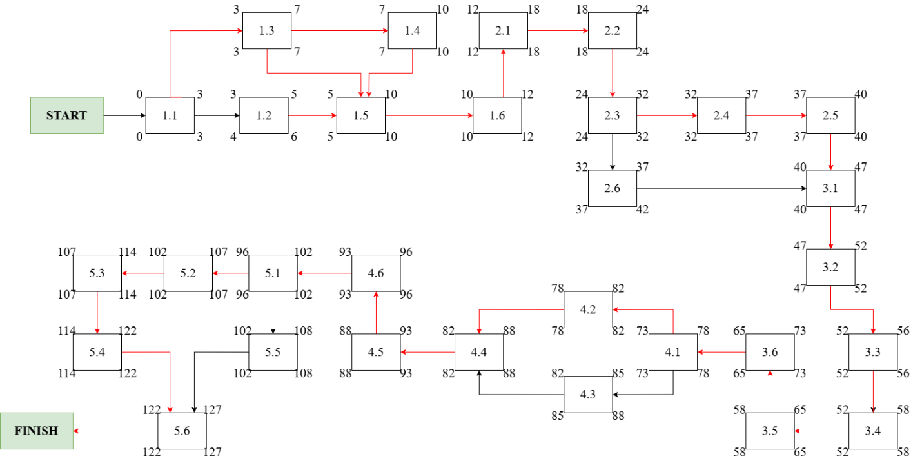

Figure 5 Critical Path Diagram

The **Figure 5 Critical Path Diagram** The team's ability to track developments, foresee any setbacks, and implement remedial actions in real time is improved by the CPM diagram. Through preemptive detection of any bottlenecks and effective resource allocation, the project team can sustain consistent advancement and guarantee the successful delivery of the Smart Home Control Application. The diagram also acts as a communication tool by giving stakeholders a succinct and understandable summary of the project's dependencies and timetable. This guarantees that everyone involved is aware of the project's status and any actions needed to keep it on course.

By analyzing the CPM diagram, project managers can proactively manage scheduling risks and implement appropriate strategies, such as fast-tracking or crashing, to compress the schedule if necessary. The diagram also highlights non-critical tasks, which have slack time and can be delayed without affecting the project's end date. This distinction helps optimize resource allocation by allowing flexibility in scheduling non-critical tasks while ensuring critical tasks are prioritized.

Moreover, the CPM diagram serves as a communication tool for stakeholders by presenting a clear and concise view of the project timeline. It facilitates better coordination among team members, enhances decision-making, and ensures that all stakeholders are aligned in their understanding of the project’s progress and critical tasks. This structured approach to project management enables timely interventions when delays occur, ensuring that the Smart Home Control Application is delivered successfully, meeting all technical and stakeholder requirements.

### Project Deviation and Variance

When evaluating project performance in comparison to the initial plan, project deviation and variance are essential. When schedules, resource utilisation, or task completion diverge from the original plan, this is referred to as deviation. As a quantitative metric, variance aids in assessing how much the project deviates from expectations. Whereas a negative variance suggests delays or overspending, a positive variance shows that the project is on track or under budget.   
Project managers can find trouble spots and take corrective action to keep the project on schedule by monitoring deviations and variances. By acting as early warning signs, these metrics enable proactive management and lower the likelihood of significant setbacks. Constant observation guarantees timely delivery and conformity with project objectives.

Finding the standard deviation on the critical path is essential for efficiently quantifying variance. Project managers can calculate the likelihood that the project will be finished within the allotted time by using a Z-index formula. This strategy increases the likelihood that a project will succeed and encourages improved decision-making. The following formula, which determines the Z-index and gives us the standard deviation value, can be used to accomplish this:

Where:

**D -** Desired time estimate, representing the total duration based on beta distribution estimates.

- Mean time estimate, which is the summation of activities on the critical path.

- Standard deviation of the critical path, representing the variability in the time estimates.

**z -**  Z-index, which indicates how many standard deviations the desired duration (D) is away from the mean duration (μ). This helps in determining the probability of completing the project within the desired time frame.

In the Development of a Smart Home Control Application project, the desired time estimate (**D**) is set at **22 weeks**, representing the total planned duration for project completion. The mean time estimate (**μ**) for the critical path is calculated to be **21 weeks**, summing up the expected durations of critical activities. The standard deviation of the critical path (**σμ**) is **1.41 weeks**, accounting for variability in time estimates. When these values are plugged into the Z-index formula, a Z-value of **0.09** is obtained, corresponding to a **probability of approximately 54%** that the project will be completed on time. This result suggests a reasonably high confidence level in meeting the project deadline, provided that potential risks are effectively managed, and key milestones are achieved as planned.

**Project completion uncertainty:** At the moment, we are focussing on figuring out how certain we are that the project will be finished on schedule. Given our estimated 152-day timeline, roughly half of the project should be completed by then under normal conditions. However, considering the possible influence of outside variables on the project, we want to evaluate the likelihood of finishing it either ahead of or behind the initial timeline. In order to perform these evaluations, we will utilise a certain formula:

In this context, Z denotes the probability associated with each duration, D signifies the observed values, **μ** represents the duration time, and **σ** stands for the standard deviation. The next step is to determine the value of **σ**, which is specified as the standard deviation. The initial step involves calculating **σ²**, which, in this case, is the sum of the variances of activities with zero slack time. This computation is performed using an Excel spreadsheet, yielding the following result: Summation of **σ² = 126.15**. This value, which signifies the variance in the normal distribution, is denoted by **σ²**. Now that we have acquired the **σ²** value, the subsequent step involves calculating the actual **σ** value by taking the square root of the computed result. Upon completion of this calculation, we obtain **σ = 11.23 weeks**.

The final step involves using the Z-index formula with **D = 152 days** **μ = 151 days**, and **σ = 11.23 days**. The concluding step entails comparing various values of D, where D represents the duration time. We will identify both the highest and lowest values and subsequently analyze the results. The **Table 5** below provides a clear representation of these outcomes:

|  |  |  |  |
| --- | --- | --- | --- |
| D - value | Z - value | Z – table | Probability |
| 151 days | -0.09 | 0.4645 | 46.45% |
| 152 days | 0.00 | 0.5000 | 50.00% |
| 153 days | 0.09 | 0.5355 | 53.55% |
| 154 days | 0.18 | 0.5707 | 57.07% |

Table 5 Uncertainty of Project Completion

**Table 5** illustrates the uncertainty in project completion by presenting a range of possible project durations (D-values), their corresponding Z-values, Z-table lookups, and the resulting probabilities. The D-values, expressed in days, represent the different possible completion times around the desired time estimate. For each D-value, a Z-value is calculated using the formula ​, where μ=34 weeks is the mean time estimate for the critical path, and σ=11.23 weeks is the standard deviation of the critical path. These Z-values provide a standardized measure of how far each D-value deviates from the mean project duration.

The cumulative probability of finishing the project within the given D-value is found using the Z-table lookup for each Z-value. The chance that the project will be finished on schedule or ahead of schedule is represented by the cumulative probability. For example, the Z-value of 0.09 indicates a probability of roughly 53.55% for a D-value of 152 days. Because activity durations vary, there is a 53.55% chance that the project will be finished in 152 days, underscoring the inherent unpredictability in project timeframes.

The table also reveals that as the D-values increase, the probabilities tend to rise, reflecting the increased likelihood of project completion as more time is allotted. This analysis helps project managers assess the risk of potential delays and plan accordingly by setting realistic expectations and identifying tasks with high variability that may impact overall completion. By providing a clear representation of different project scenarios, **Table 5** aids in decision-making and ensures proactive management of the project schedule.

## GANT CHART

When developing a Smart Home Control Application project, the Gantt chart is an essential tool since it provides a clear visual depiction of the project timetable, important milestones, and task dependencies. The chart allows the project team to monitor progress and guarantee that each work is completed on time by segmenting the entire project into manageable segments. The Gantt chart gives information about the order of work in addition to highlighting key path activities. Additionally, it assists the project manager in keeping a precise record of the project lifecycle and guaranteeing that deadlines are fulfilled without sacrificing quality. Furthermore, by breaking the project up into several phases, the team can concentrate on accomplishing more manageable, well-defined objectives, which enhances the project's overall success.

One of the key features of this Gantt chart (**Figure 6**) is the capacity to show tasks that overlap and their corresponding durations. By identifying jobs that can be completed concurrently, the team is able to maximise the project timeframe without sacrificing quality thanks to this overlap. Milestones, which stand for significant project deliverables including the completion of UI design, device integration, and system testing, are also clearly defined. These milestones offer checkpoints that guarantee timely progress evaluations and assist the project team in maintaining alignment with the overarching objectives. Effective resource management is also supported by the chart, which makes sure that team members are given duties without being overworked. Milestones serve as crucial checkpoints that allow the team to assess progress and make necessary adjustments to plans.

Moreover, the Gantt chart (**Figure 6**) facilitates proactive project management by allowing for adjustments in real time. The Gantt chart serves as a dynamic tool that not only illustrates the project timeline but also adapts to evolving project conditions, making it indispensable for effective project management. Its ability to be updated in real-time allows project managers to quickly reflect changes, such as delays or resource reallocations, ensuring that the project remains on track despite unforeseen challenges. When delays occur, the Gantt chart can highlight critical path tasks that require immediate attention, enabling prompt decision-making to mitigate risks and maintain the overall project schedule. Similarly, when resources need to be redistributed, the chart offers a clear overview of task dependencies and timelines, helping to reallocate efforts where they are most needed without disrupting workflow.

Moreover, the Gantt chart fosters collaboration across the project team by providing a shared visual framework that enhances clarity and accountability. Team members can easily track their responsibilities, deadlines, and progress, which promotes better coordination and cooperation. By clearly outlining task sequences and milestones, the chart helps prevent misunderstandings and ensures that everyone remains aligned toward common project goals. This transparency not only improves internal communication but also strengthens stakeholder engagement. External stakeholders can quickly grasp the project’s current status, upcoming milestones, and any potential risks, which fosters trust and confidence in the project’s successful completion.

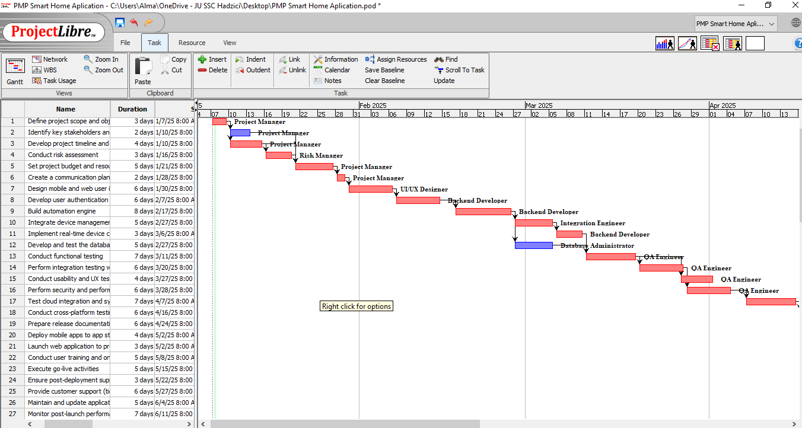

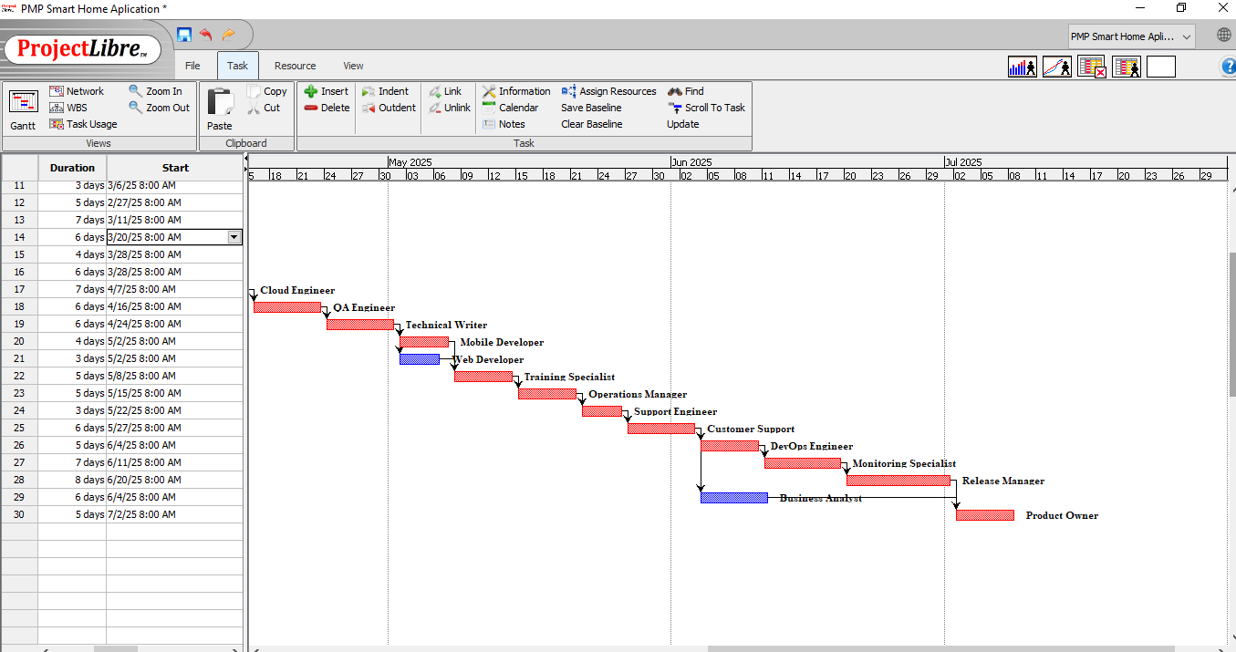

Figure 6 Gant Chart

When developing a Smart Home Control Application project, the Gantt chart is an essential tool because it provides a thorough and understandable visual depiction of the project timetable, significant milestones, task dependencies, and overall progress. The Gantt chart helps the project team to better track progress and retain clarity on deliverables by segmenting the entire project into manageable periods. Due to the clear representation of each project phase, stakeholders are able to keep a close eye on task progress, guaranteeing that every activity is completed on time.

The Gantt chart does not only highlight critical path activities—the tasks that directly affect the overall project timeline—but also provides a clear sequence of tasks, helping to identify potential bottlenecks early and allocate resources efficiently. This visual tool empowers the project manager to maintain a complete overview of the project lifecycle, ensuring that deadlines are consistently met without compromising quality or scope. Additionally, by segmenting the project into smaller, well-defined stages, the team can focus on incremental goals, which collectively contribute to the broader success of the project. This structured approach minimizes risks, enhances accountability, and ensures better handling of time-sensitive tasks.

A detailed analysis of the Gantt chart **(Figure 6)** reveals critical elements such as overlapping tasks, dependencies, and major milestones that represent key deliverables throughout the project lifecycle. Significant phases, including UI design, device management integration, testing, and deployment, are clearly outlined in the chart, ensuring that tasks critical to project success are given appropriate attention. By highlighting tasks that can be performed in parallel, the Gantt chart helps the team identify opportunities to fast-track the project timeline and reduce delays through concurrent task execution. For instance, the milestone "Completion of UI Design" is set for week 4, which directly impacts the subsequent phase, "Device Management Integration Complete" in week 15, followed by "Testing Completion" in week 40. These milestones serve as crucial checkpoints in the project, ensuring timely completion of core phases and providing opportunities for the team to make necessary adjustments if any delays occur or risks are identified during earlier stages.

Moreover, the Gantt chart **(Figure 6)** offers critical insights into task durations, interdependencies, and resource allocation across various phases of the project. It enables the project team to see how tasks flow from one phase to another, ensuring that each phase is logically sequenced to minimize workflow interruptions. By updating the Gantt chart in real-time, the project manager can continuously monitor actual progress against planned progress, quickly identifying any deviations from the schedule. This dynamic feature allows for immediate response to unforeseen delays, enabling the team to reallocate resources or adjust timelines as necessary to maintain project momentum. Additionally, this real-time visibility into project performance helps stakeholders stay informed, promoting transparency and encouraging better collaboration among all involved parties. By visually presenting the entire project timeline, the Gantt chart not only aids in effective time management but also serves as a valuable communication tool, ensuring that everyone remains aligned with project goals. Ultimately, this level of structured planning, combined with ongoing monitoring and communication, helps ensure the successful delivery of the Smart Home Control Application within the defined time frame and budget constraints.

# COST/BUDGET management

Cost and budget management are critical components of the Development of a Smart Home Control Application project, ensuring that resources are utilized effectively and the project remains financially viable. Proper cost management is essential to meet the financial goals of the project, avoid unnecessary expenditures, and maintain a balance between quality, scope, and financial constraints. This chapter outlines the strategies and processes for estimating, allocating, and controlling costs throughout the project lifecycle. By establishing a detailed budget and cost control mechanisms, the project team can maintain financial discipline, ensure proper resource allocation, and prevent cost overruns. A well-structured approach to cost and budget management ensures that project objectives are met without compromising the financial health of the project.

The cost management process begins with the development of a comprehensive cost estimation framework that takes into account all aspects of the project, including hardware, software, labor, and operational expenses. This framework serves as a blueprint for financial planning, ensuring that no critical cost element is overlooked. The estimation process is guided by industry best practices, expert judgment, and historical data from similar projects, thereby improving the accuracy of cost predictions. Key cost elements are categorized into different phases of the project lifecycle, such as development, testing, deployment, and post-launch support. This categorization helps in better tracking and managing expenditures. Furthermore, contingency reserves are incorporated to account for unforeseen expenses, ensuring that the project remains resilient to potential financial risks and uncertainties. These reserves act as a buffer, providing the flexibility to handle unexpected challenges without derailing the project’s financial plan.

A crucial component of the cost management process is continuing cost control, which goes hand in hand with initial cost estimation. Mechanisms for ongoing reporting and monitoring are put in place to make sure that actual spending matches the budgeted amount. Any departures from the allocated sums are found by routine variance analysis, and swift remedial action is done to reduce the possibility of cost overruns. Earned value management (EVM) is one of the tools and strategies used to give a quantitative assessment of project performance. The project team may make well-informed decisions and properly predict future costs by using EVM to compare planned work with actual progress and expenses. The project team can take proactive measures to resolve financial concerns before they worsen by utilising these cutting-edge cost management technologies.

Effective communication with stakeholders is another critical element of cost management. Regular financial reports and updates are provided to key stakeholders, ensuring transparency and fostering trust. Stakeholder involvement in cost management activities helps in setting realistic financial expectations and securing necessary support for any budgetary adjustments. Additionally, periodic cost reviews are conducted to assess the overall financial health of the project, identify potential cost-saving opportunities, and optimize resource utilization. These reviews also serve as checkpoints to ensure that the project remains on track financially.

Another important aspect of cost management is resource optimization. By ensuring that resources are allocated efficiently, the project team can maximize productivity while minimizing unnecessary expenses. This involves careful planning and scheduling of tasks, procurement of cost-effective hardware and software, and leveraging automation tools to reduce manual efforts. The use of modern project management software for tracking and managing costs further enhances the team’s ability to stay within budget.

In conclusion, cost and budget management play a pivotal role in the successful execution of the Development of a Smart Home Control Application project. A structured approach to cost estimation, allocation, monitoring, and control helps in maintaining financial discipline, optimizing resource utilization, and delivering a high-quality product within the defined budget. By employing industry best practices, advanced cost management tools, and effective stakeholder communication, the project team can ensure that financial goals are met and that the project delivers value to all stakeholders. A robust cost management plan not only ensures the project’s financial viability but also enhances its overall success by enabling timely delivery, maintaining quality standards, and fostering stakeholder confidence.

## Resource Plan (Tables and Gant Chart)

The table titled **Figure 7: Table of Resources and Materials** provides a comprehensive and detailed overview of the human resources and materials allocated for the "Development of a Smart Home Control Application" project. This table is an integral component of the project’s resource management plan, ensuring that both personnel and material requirements are clearly identified and appropriately managed. Effective resource management is critical to the success of any project, and this table serves as a foundational tool for ensuring that resources are utilized efficiently, costs are controlled, and project objectives are met within the specified timeline and budget.

The first section of the table focuses on human resources, listing essential roles required for the successful execution of the project. Key roles such as Project Manager, Business Analyst, Project Scheduler, Risk Manager, Backend Developer, and QA Engineer are highlighted, with each role assigned a specific RBS (Resource Breakdown Structure) cost. The table also includes columns for resource type, initials for easy identification, maximum units (availability), and standard daily rates. The RBS cost represents the allocated budget for each resource, ensuring that financial constraints are adhered to during project execution. The resource type column categorizes each entry as "Work," indicating that these are human resources contributing directly to project activities. The Max Units column indicates the percentage of time that each resource is available, with 100% representing full-time availability. The Standard Rate column provides the daily rate for each resource, which is essential for tracking labor costs and ensuring that expenditures remain aligned with the project budget. These details enable the project management team to plan, allocate, and monitor resources effectively, minimizing the risk of over-allocation or under-utilization.

The project's material resources, such as hardware components, software licenses, testing apparatus, prototyping tools, training materials, travel expenses, and a contingency budget, are listed in the second portion of the table. The cost of each material resource is determined by its contribution to the project's overall budget. While testing equipment and prototyping tools are essential for the project's design and testing phases, hardware components and software licenses are crucial for the project's development and deployment phases. Training materials are essential for user onboarding and guaranteeing end users' seamless adoption of the smart home application. Travel Costs are included to cover any necessary travel expenses incurred by the project team during various phases of the project. The Contingency Budget is an important component of the cost management strategy, providing a financial buffer to handle unforeseen expenses and risks that may arise during the project lifecycle.

By providing a holistic view of both work-related resources and material requirements, this table serves as a vital reference for the project management team. It facilitates better decision-making by offering clear insights into the costs and availability of resources, ensuring that tasks are assigned appropriately and that the project remains on track financially. Additionally, the table supports variance analysis by enabling the comparison of planned versus actual costs, allowing the project team to take timely corrective actions in case of deviations. Overall, the inclusion of both personnel and material resources in a single table enhances the project’s transparency, accountability, and efficiency. This structured approach to resource management ensures that the "Development of a Smart Home Control Application" project is executed successfully, delivering 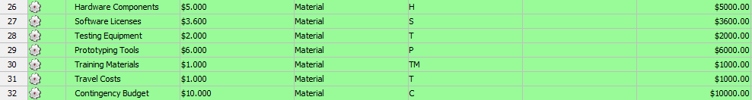a high-quality product within the defined budget and timeline while maintaining stakeholder 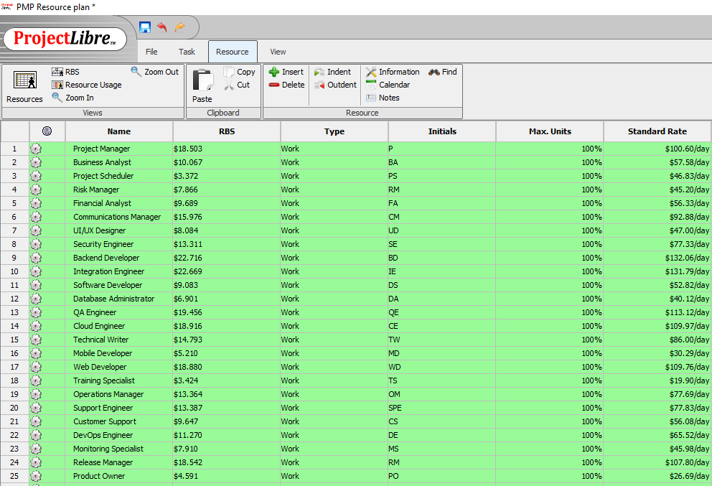confidence.

Figure 7 Resources and Materials

**The Figure 7 Resources and Materials** provides a detailed breakdown of all human and material resources allocated for the "Development of a Smart Home Control Application" project. This resource management table plays a pivotal role in ensuring efficient use of resources, maintaining budgetary control, and tracking the progress of the project. The table is divided into two key sections: human resources (work type) and material resources, each of which contributes uniquely to the successful execution of the project. By clearly defining each resource's role and associated cost, the project team can effectively manage resource utilization, ensure accurate cost estimation, and maintain control over the overall budget.

The first section of the table focuses on human resources, listing critical roles such as Project Manager, Business Analyst, Project Scheduler, and various technical experts including Backend Developer, QA Engineer, and Cloud Engineer. For each role, key details are provided, including the Resource Breakdown Structure (RBS) cost, type, initials for identification, maximum availability (Max Units), and standard daily rates. The RBS column specifies the allocated budget for each resource, while the Standard Rate column provides the daily cost of utilizing the resource. This structured approach ensures that financial constraints are adhered to while maintaining the required workforce for different phases of the project, including development, testing, and deployment. Additionally, the availability data ensures that resources are neither over-allocated nor under-utilized, enabling the project team to assign tasks efficiently and avoid delays.

The second section lists material resources essential for project execution, such as Hardware Components, Software Licenses, Testing Equipment, Prototyping Tools, Training Materials, Travel Costs, and a Contingency Budget. Each material is assigned a specific cost, reflecting its contribution to the overall project budget. Hardware Components and Software Licenses are critical during the development phase, while Testing Equipment and Prototyping Tools support the testing and design phases. Training Materials ensure effective user onboarding, and Travel Costs cover necessary travel expenses for team activities. The inclusion of a Contingency Budget provides a financial buffer to manage unexpected costs, enhancing the project’s resilience against risks. By integrating both human and material resources in a single comprehensive table, the project management team can cross-reference this data with the project schedule and budget to maintain transparency, accountability, and financial control throughout the project lifecycle.

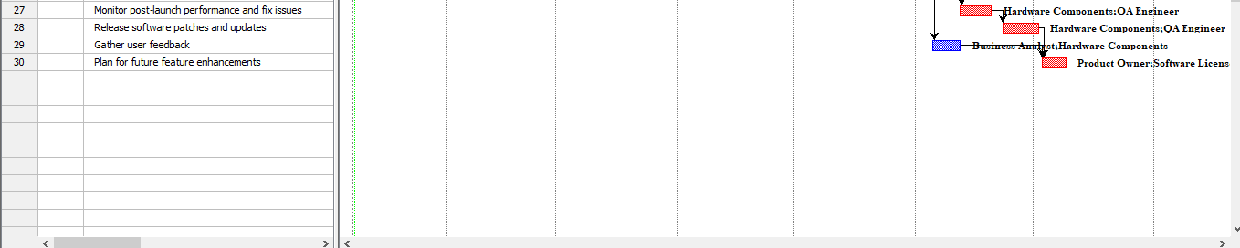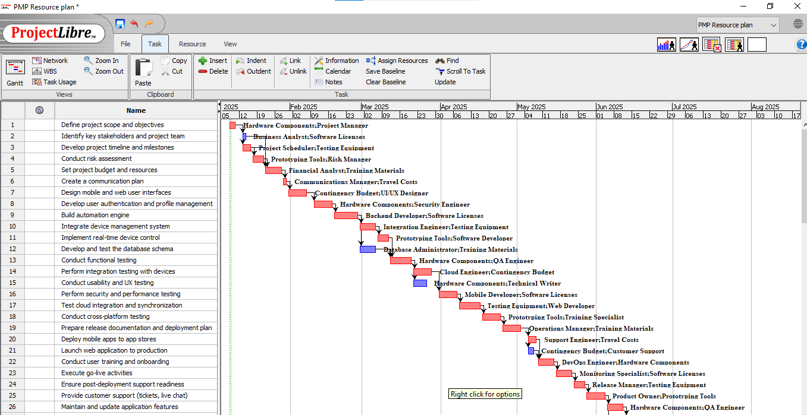

Figure 8 Gantt Chart for Resource Plan

**Figure 8 Gantt Chart for Resource** **Plan** provides a comprehensive and professional depiction of the project timeline for the **Development of a Smart Home Control Application**. It visually illustrates the sequence of tasks, their scheduled start and end dates, and the interdependencies between them. The left-hand side of the chart lists all project tasks in a hierarchical manner, encompassing the entire project duration. Every task is shown as a horizontal bar, the length of which indicates how long the activity should take. To guarantee that the project moves forward in a planned and regulated way, important stages including project scope definition, core product development, testing, and deployment preparation are underlined. The Gantt chart plays a crucial role in measuring progress, allocating resources, and guaranteeing that the project timeline is followed.

A critical feature of this Gantt chart is the clear visualization of **task dependencies and critical paths**. Tasks linked by arrows indicate dependency relationships, signifying that certain tasks must be completed before subsequent activities can commence. The chart uses color-coded bars to distinguish between critical and non-critical tasks. Red bars represent tasks on the critical path, which directly influence the project's completion date—any delay in these tasks would impact the overall project timeline. Blue bars denote dependent tasks that, while not on the critical path, still play a vital role in the project's successful execution. By clearly identifying these critical elements, the Gantt chart enables proactive risk management and ensures that high-priority tasks receive the necessary attention to avoid project delays.

Additionally, the Gantt chart provides detailed information on **resource and material allocation** for each task, ensuring that all project activities are adequately supported. Tasks such as **user interface design** are assigned to UI/UX Designers, while **integration and testing activities** involve Backend Developers and QA Engineers. The chart also indicates the use of essential materials, including **hardware components**, **software licenses**, **testing equipment**, and **prototyping tools**, which are allocated to specific tasks to ensure resource availability at the right time. This structured approach to resource and material management ensures operational efficiency, minimizes the risk of resource conflicts, and supports the timely completion of project deliverables. Overall, this Gantt chart serves as a critical tool for project management, enabling precise scheduling, resource optimization, and real-time progress monitoring, thereby contributing significantly to the successful delivery of the Smart Home Control Application.

## Resource plan

In order to effectively finish the project, the resource plan for developing a smart home control application lists the essential tools, equipment, and human resources. Meeting project milestones on schedule, within scope, and within budget depends on efficient resource management. This plan outlines the project team's duties and responsibilities, specifies the technical resources that are required, and shows how these resources will be distributed across the project's several stages.

Given the complexity of this project, it is essential to assign resources efficiently to critical tasks such as system design, development, testing, and deployment. The selected team members possess the requisite skills and experience in areas such as software development, IoT integration, UI/UX design, and quality assurance. The project also leverages cloud-based tools, development platforms, and testing environments to streamline the execution of tasks.

The detailed **Table 6 Resource Plan** provides a breakdown of resources assigned to each activity, including their roles, effort estimations, and timelines. This structured approach ensures proper workload distribution and helps mitigate risks associated with resource overutilization or underutilization. Furthermore, periodic reviews and adjustments to the resource plan will be conducted to accommodate any changes in project requirements or timelines.

|  |  |  |  |  |
| --- | --- | --- | --- | --- |
| **Activity ID** | **Activity Name** | **Duration (days)** | **Predecessors** | **Assigned Resource** |
| 1.1 | Define project scope and objectives | 3 | NONE | Project Manager |
| 1.2 | Identify key stakeholders and project team | 2 | 1.1 | Project Manager |
| 1.3 | Develop project timeline and milestones | 4 | 1.1 | Project Manager |
| 1.4 | Conduct risk assessment | 3 | 1.3 | Risk Manager |
| 1.5 | Set project budget and resources | 5 | 1.2,1.3,1.4 | Project Manager |
| 1.6 | Create a communication plan | 2 | 1.5 | Project Manager |
| 2.1 | Design mobile and web user interfaces | 6 | 1.6 | UI/UX Designer |
| 2.2 | Develop user authentication and profile management | 6 | 2.1 | Backend Developer |
| 2.3 | Build automation engine | 8 | 2.2 | Backend Developer |
| 2.4 | Integrate device management system | 5 | 2.3 | Integration Engineer |
| 2.5 | Implement real-time device control | 3 | 2.4 | Backend Developer |
| 2.6 | Develop and test the database schema | 5 | 2.3 | Database Administrator |
| 3.1 | Conduct functional testing | 7 | 2.5, 2.6 | QA Engineer |
| 3.2 | Perform integration testing with devices | 5 | 3.1 | QA Engineer |
| 3.3 | Conduct usability and UX testing | 57 | 3.2 | QA Engineer |
| 3.4 | Perform security and performance testing | 6 | 3.2 | QA Engineer |
| 3.5 | Test cloud integration and synchronization | 7 | 3.4 | Cloud Engineer |
| 3.6 | Conduct cross-platform testing | 8 | 3.5 | QA Engineer |
| 4.1 | Prepare release documentation and deployment plan | 5 | 3.6 | Technical Writer |
| 4.2 | Deploy mobile apps to app stores | 4 | 4.1 | Mobile Developer |
| 4.3 | Launch web application to production | 3 | 4.1 | Web Developer |
| 4.4 | Conduct user training and onboarding | 6 | 4.2, 4.3 | Training Specialist |
| 4.5 | Execute go-live activities | 5 | 4.4 | Operations Manager |
| 4.6 | Ensure post-deployment support readiness | 3 | 4.5 | Support Engineer |
| 5.1 | Provide customer support (tickets, live chat) | 6 | 4.6 | Customer Support |
| 5.2 | Maintain and update application features | 5 | 5.1 | DevOps Engineer |
| 5.3 | Monitor post-launch performance and fix issues | 7 | 5.2 | Monitoring Specialist |
| 5.4 | Release software patches and updates | 8 | 5.3 | Release Manager |
| 5.5 | Gather user feedback | 6 | 5.1 | Business Analyst |
| 5.6 | Plan for future feature enhancements | 5 | 5.4, 5.5 | Product Owner |

Table 6 Resource Plan

**Table 6** provides a comprehensive **Resource Plan** for the **Development of a Smart Home Control Application**, detailing the human resources assigned to each activity throughout the project. The table includes key information such as the duration of each activity, their predecessors, and the corresponding resource roles necessary to ensure successful project execution. By assigning specific roles to each task, the resource plan ensures that all project phases—from initiation and planning to development, testing, and deployment—are covered by the appropriate expertise. Critical roles such as **Project Manager**, **UI/UX Designer**, **Backend Developer**, and **QA Engineer** are assigned to core tasks, reflecting the diverse range of skills required to deliver a reliable and user-friendly smart home control solution.

The resource allocation covers all major project phases and assigns specific responsibilities to team members. In the initial planning stage, the **Project Manager** leads activities such as defining project scope, identifying stakeholders, and setting the budget. During the design and development stages, roles such as **UI/UX Designer**, **Backend Developer**, and **Database Administrator** are responsible for building and integrating key system components, ensuring a functional and scalable platform. The QA Engineer oversees functional, integration, and usability testing as the project moves into the testing phase to make sure the product satisfies high standards. A seamless transition into production is ensured by assigning specialised roles, such as Cloud Engineer, Technical Writer, and Release Manager, later on to handle cloud integration, documentation, and deployment duties.

Efficient resource utilization is a core focus of the plan. By specifying task durations and defining logical predecessors, the table ensures that activities are sequenced correctly, avoiding delays and resource bottlenecks. For instance, deployment tasks assigned to the **Mobile Developer** and **Web Developer** are only initiated once the testing and documentation activities are completed. Post-deployment responsibilities such as customer support, monitoring, and future planning are assigned to roles like **Customer Support**, **Monitoring Specialist**, and **Product Owner**, ensuring continuous improvement and user satisfaction. This systematic resource allocation approach minimizes risks, enhances team productivity, and ultimately increases the likelihood of delivering a successful smart home control application on time and within budget.

## Budget plan

The Budget Plan for our project is a critical element of our project management strategy, meticulously developed to provide a clear financial framework for the Development of a Smart Home Control Application. It is designed to support informed decision-making by offering detailed cost estimates and a structured approach to resource allocation. The budget outlines projected expenses for personnel, materials, administrative overhead, and external services such as cloud hosting and consulting. Each cost component was carefully analyzed and categorized, enabling precise financial planning. Personnel costs, which represent a significant portion of the budget, are calculated based on the hourly rates of key team members, including UI/UX designers, backend developers, QA engineers, and cloud specialists. Material costs include essential hardware components, software licenses, and infrastructure services required to develop and deploy a fully functional smart home solution. This systematic breakdown ensures that all project aspects are financially accounted for from the outset.

An essential feature of our budget is the inclusion of a contingency reserve, set aside to manage unforeseen events or changes in project scope. This proactive approach mitigates financial risks and helps maintain project momentum, even when unexpected issues arise. The contingency allocation is based on industry best practices, ensuring an adequate buffer without inflating the overall budget. To enhance financial management, funds are allocated by project phase and milestone, ensuring that each critical stage, such as system design, development, testing, and deployment, is sufficiently funded. This phased distribution enables us to prioritize spending according to project progress, ensuring resources are available when needed.

To strengthen financial transparency and oversight, we have established a formal budget approval and sign-off process involving key stakeholders. This process ensures that budget adjustments or significant financial decisions are aligned with project goals and receive proper authorization. Regular financial reporting and monitoring are integral parts of our budget plan, providing a continuous review of actual expenditures versus planned costs. **Table 7 Resource Budget for Personnel and Materials Materials** offers a comprehensive breakdown of the resources required for each activity, detailing both human and material inputs. The table underscores the interdisciplinary nature of the project, emphasizing the diverse expertise needed to create a high-quality smart home control application. By leveraging advanced project management tools, we aim to ensure that financial resources are managed effectively, risks are minimized, and project goals are achieved within the defined financial parameters.

|  |  |  |
| --- | --- | --- |
| **Resource No.** | **Resource Names** | **Cost ($)** |
| 1 | Project Manager | $18.503 |
| 2 | Business Analyst | $10.067 |
| 3 | Project Scheduler | $3.372 |
| 4 | Risk Manager | $7.866 |
| 5 | Financial Analyst | $9.689 |
| 6 | Communications Manager | $15.976 |
| 7 | UI/UX Designer | $8.084 |
| 8 | Security Engineer | $13.311 |
| 9 | Backend Developer | $22.716 |
| 10 | Integration Engineer | $22.669 |
| 11 | Software Developer | $9.083 |
| 12 | Database Administrator | $6.901 |
| 13 | QA Engineer | $19.456 |
| 14 | Cloud Engineer | $18.916 |
| 15 | Technical Writer | $14.793 |
| 16 | Mobile Developer | $5.210 |
| 17 | Web Developer | $18.880 |
| 18 | Training Specialist | $3.424 |
| 19 | Operations Manager | $13.364 |
| 20 | Support Engineer | $13.387 |
| 21 | Customer Support | $9.647 |
| 22 | DevOps Engineer | $11.270 |
| 23 | Monitoring Specialist | $7.910 |
| 24 | Release Manager | $18.542 |
| 25 | Product Owner | $4.591 |
| 26 | Hardware Components | $5.000 |
| 27 | Software Licenses | $3.600 |
| 28 | Testing Equipment | $2.000 |
| 29 | Prototyping Tools | $6.000 |
| 30 | Training Materials | $1.000 |
| 31 | Travel Costs | $1.000 |
| 32 | Contingency Budget | $10.000 |
|  | Total | $335.227 |

Table 7 Resource Budget for Personnel and Materials

The **Table 7 Resource Budget for Personnel and Materials** gives a thorough explanation of the projected costs for every resource needed to finish developing a smart home control application. This table ensures appropriate financial planning for the project by listing all of the important persons and their associated expenditures. The expenses of each resource are commensurate with their importance in the project lifecycle, and each resource is essential to reaching the project's milestones. In order to ensure accurate budget estimation, key positions like project manager, business analyst, and UI/UX designer are assigned particular charges based on realistic industry rates. Technical experts that are crucial to the fundamental development and security of the smart home application, such as database administrators, security engineers, and backend developers, are also included in the table.

In addition to development and design roles, the table accounts for resources necessary during the later phases of the project, such as **QA Engineer**, **Cloud Engineer**, and **Technical Writer**, who ensure the quality and documentation of the final product. Specialized roles such as **Support Engineer** and **Customer Support** are allocated costs to handle post-deployment activities, ensuring smooth operations and user satisfaction after the project goes live. By including both core development resources and post-deployment support, the resource cost table ensures a well-rounded financial plan covering all phases of the project lifecycle. This holistic approach is designed to mitigate risks associated with underfunding critical tasks and roles.

The entire expected cost of all resources is shown in the table's last row, giving stakeholders a clear picture of the project's financial needs. All personnel-related costs are included in the total cost, which guarantees that money is distributed effectively without going above the project's overall budget. From early planning to final deployment, this methodical financial planning guarantees that there are enough resources available at every step of the project. To maintain financial management throughout the project, real spending will be regularly compared to the budgeted amount. Periodic financial evaluations and the comprehensive resource cost table will assist guarantee that the project stays on schedule and under budget.

## Resource cost

A thorough financial summary of the anticipated costs related to each resource needed to finish the project is given by the Resource Cost Calculation for the Development of a Smart Home Control Application. A crucial component of the overall budget plan, this computation makes sure that the distribution of funds is in line with the goals and specifications of the project. The project team can predict and budget for the cash outlay required for every stage of the project, from early planning and design to development, testing, and deployment, by figuring out resource costs.

The first step in calculating resource costs is to identify the most important resources, such as technical elements like software tools and cloud infrastructure, as well as human resources like project managers, developers, and quality assurance engineers. Each resource that has been identified is given a precise cost rate, which is usually stated as a set price for material resources or an hourly rate for personnel. The given rate is then multiplied by the projected consumption or effort in hours to determine the overall cost for each resource. This method guarantees accurate budgeting and offers a clear picture of how funds are allocated among various jobs and pursuits.

The resource cost computation is used to improve financial transparencyis presented in **Table 8 Resource Cost,** this provides a comprehensive cost summary for every resource used in the project. Resource names, hourly rates, expected hours, and total expenses are all shown in columns of this table. The table helps stakeholders keep an eye on and manage costs throughout the project lifetime by offering a clear and organised perspective of resource expenditures. Additionally, it helps with proactive financial management and well-informed decision-making, guaranteeing that the project stays within its authorised budget while producing the intended results.

|  |  |  |  |
| --- | --- | --- | --- |
| **Activity No.** | **Activity Name** | **Duration (days)** | **Total Cost ($)** |
| 1 | Define project scope and objectives | 3 | $6282.19 |
| 2 | Identify key stakeholders and project team | 2 | $2119.29 |
| 3 | Develop project timeline and milestones | 4 | $9385.45 |
| 4 | Conduct risk assessment | 3 | $3406.01 |
| 5 | Set project budget and resources | 5 | $6181.28 |
| 6 | Create a communication plan | 2 | $3078.02 |
| 7 | Design mobile and web user interfaces | 6 | $6206.51 |
| 8 | Develop user authentication and profile management | 6 | $8628.56 |
| 9 | Build automation engine | 8 | $18972.73 |
| 10 | Integrate device management system | 5 | $5298.24 |
| 11 | Implement real-time device control | 3 | $7114.77 |
| 12 | Develop and test the database schema | 5 | $5676.68 |
| 13 | Conduct functional testing | 7 | $10773.08 |
| 14 | Perform integration testing with devices | 5 | $12362.55 |
| 15 | Conduct usability and UX testing | 4 | $77657.01 |
| 16 | Perform security and performance testing | 6 | $8779.93 |
| 17 | Test cloud integration and synchronization | 7 | $13245.59 |
| 18 | Conduct cross-platform testing | 8 | $18569.06 |
| 19 | Prepare release documentation and deployment plan | 5 | $7442.76 |
| 20 | Deploy mobile apps to app stores | 4 | $10091.88 |
| 21 | Launch web application to production | 3 | $3633.08 |
| 22 | Conduct user training and onboarding | 6 | $12867.15 |
| 23 | Execute go-live activities | 5 | $9334.99 |
| 24 | Ensure post-deployment support readiness | 3 | $5146.86 |
| 25 | Provide customer support (tickets, live chat) | 6 | $9385.45 |
| 26 | Maintain and update application features | 5 | $6433.57 |
| 27 | Monitor post-launch performance and fix issues | 7 | $14835.06 |
| 28 | Release software patches and updates | 8 | $12312.09 |
| 29 | Gather user feedback | 6 | $8779.93 |
| 30 | Plan for future feature enhancements | 5 | $11227.22 |
|  |  | TOTAL: | $335.227 |

Table 8 Resource Cost

**Table 8 Resource Cost** provides a detailed breakdown of the resource costs associated with each activity in the **Development of a Smart Home Control Application**. For each activity, the table lists its duration, the assigned resource, and the corresponding cost, which has been calculated based on realistic industry rates. This structured approach ensures that the financial requirements for each project phase are estimated accurately, covering key tasks such as project scope definition, risk assessment, UI/UX design, backend development, and testing. High-cost activities like **designing mobile and web user interfaces**, **developing user authentication**, and **integration testing** represent their vital part in the smart home application's effective implementation. Table 8 gives the project team and stakeholders a clear cost structure that makes it possible to efficiently manage spending and guarantee that resources are assigned to the appropriate tasks at the appropriate times.

The resource cost calculation emphasizes the importance of proper resource management in controlling project expenses. Key roles such as **Project Manager**, **Backend Developer**, and **QA Engineer** contribute significantly to the overall budget due to their involvement in high-impact activities. Additionally, specialized roles like **Cloud Engineer**, **Security Engineer**, and **Support Engineer** are necessary to ensure the application meets industry standards in terms of security, scalability, and user satisfaction. This level of detail in resource cost estimation facilitates better financial planning, reduces the risk of cost overruns, and supports timely decision-making throughout the project lifecycle. The inclusion of resource-specific costs also ensures that the project team can monitor budget consumption in real-time and make necessary adjustments as needed.

The **Total Budget** for the project is calculated using the following formula:  
**Total Budget = Personnel Costs + Material Costs + Overhead Costs + External Services + Contingency + Other Costs**.

* **Personnel and Material Costs:** $335,227 (sum of resource costs from Table 8).
* **Overhead Costs:** $20,000 (administrative and operational expenses).
* **External Services:** $25,000 (consulting services, software licenses, and cloud infrastructure).
* **Contingency:** $33,522 (10% of the total budget to mitigate risks).
* **Other Costs:** $10,000 (miscellaneous expenses). Summing these components, the total budget amounts to **$423,749**. This comprehensive financial estimate ensures that the project has sufficient resources to meet its goals, while the contingency allocation provides a buffer for unforeseen events, supporting the successful and timely delivery of the smart home control application.

## Project crashing (Time Cost and Trade Offs)

Project crashing is a tactical method used in project management to expedite important activities and shorten the project's timetable. This approach is especially helpful when there are strict deadlines to meet or when unanticipated delays jeopardise the timely delivery of important milestones. Project crashing can assist guarantee that important stages like system integration, UI/UX design, and functional testing are completed on schedule while developing a smart home control application. The fundamental idea behind project crashing is realising that time savings frequently result in higher expenses. As a result, increasing resource allocation, using specialised technologies, or working extra may be necessary to accelerate jobs in the critical path. Crashing entails striking a balance between increased expenses and quicker completion. Additional resources are necessary to expedite important activities. It is dangerous to use crashing techniques without doing a thorough examination. Planning beforehand helps you avoid wasting time and money..

The first step in applying project crashing is identifying the critical path, which represents the sequence of tasks that directly determines the overall project duration. Once the critical path is identified, project managers assess which tasks can be shortened by allocating additional resources or using alternative techniques. In this project, activities such as **backend development**, **integration testing**, and **security/performance testing** are likely candidates for crashing, as they are pivotal to the success of the smart home control application. Crashing these activities may involve hiring more developers, employing advanced testing tools, or extending work hours. However, as shown in **Table 9 Project Crashing** accelerating these tasks incurs additional costs that must be carefully balanced against the benefits of reduced project duration. Crashing adds complexity to resource management efforts. Faster completion may result in resource burnout. Stakeholders should approve crashing efforts beforehand. Evaluating crashing feasibility is key to success.

Choosing the appropriate crashing strategy requires careful consideration of the trade-offs between time, cost, and project quality. The goal is to minimize the overall timeline while ensuring that essential features of the smart home application are delivered without compromising functionality or user experience. Effective communication with stakeholders is key, ensuring alignment on revised schedules and costs associated with crashing. The impact of crashing on project expenses and resource utilization is summarized in **Table 9**, which outlines the activities selected for crashing, the additional resources required, and the corresponding cost implications. This structured approach enables the project team to manage time-cost trade-offs effectively, ensuring that the smart home control application is delivered on time while maintaining high-quality standards. Delays can arise even after crashing efforts. Crashing works best with proper resource availability. Extra costs must justify faster completion times.

|  |  |  |  |  |  |  |  |
| --- | --- | --- | --- | --- | --- | --- | --- |
| **Activity No.** | **Activity Name** | **Duration (TE)** | **Crash Time** | **Normal Cost (USD)** | **Crash Cost (USD)** | **Slope (USD/Week)** | **CP** |
| 1 | Define project scope and objectives | 3 | 2 | 6282.19 | 7538 | 1004.65 | Yes |
| 2 | Identify key stakeholders and project team | 2 | 1 | 2119.29 | 2119.29 | 0 | No |
| 3 | Develop project timeline and milestones | 4 | 3 | 9385.45 | 11262 | 1501.24 | Yes |
| 4 | Conduct risk assessment | 3 | 2 | 3406.01 | 4087 | 544.79 | Yes |
| 5 | Set project budget and resources | 5 | 4 | 6181.28 | 7417 | 988.58 | Yes |
| 6 | Create a communication plan | 2 | 1 | 3078.02 | 3693 | 491.98 | Yes |
| 7 | Design mobile and web user interfaces | 6 | 4 | 6206.51 | 7447 | 496.19 | Yes |
| 8 | Develop user authentication and profile management | 6 | 4 | 8628.56 | 10354 | 690.18 | Yes |
| 9 | Build automation engine | 8 | 6 | 18972.73 | 22767 | 1517.71 | Yes |
| 10 | Integrate device management system | 5 | 4 | 5298.24 | 6357 | 847.01 | Yes |
| 11 | Implement real-time device control | 3 | 2 | 7114.77 | 8537 | 1137.78 | Yes |
| 12 | Develop and test the database schema | 5 | 4 | 5676.68 | 5676.68 | 0 | No |
| 13 | Conduct functional testing | 7 | 5 | 10773.08 | 12927 | 861.57 | Yes |
| 14 | Perform integration testing with devices | 5 | 4 | 12362.55 | 14835 | 1977.96 | Yes |
| 15 | Conduct usability and UX testing | 4 | 3 | 77657.01 | 93188 | 12424.79 | Yes |
| 16 | Perform security and performance testing | 6 | 4 | 8779.93 | 10535 | 702.02 | Yes |
| 17 | Test cloud integration and synchronization | 7 | 5 | 13245.59 | 15894 | 1059.36 | Yes |
| 18 | Conduct cross-platform testing | 8 | 6 | 18569.06 | 22282 | 1485.18 | Yes |
| 19 | Prepare release documentation and deployment plan | 5 | 4 | 7442.76 | 8931 | 1190.59 | Yes |
| 20 | Deploy mobile apps to app stores | 4 | 3 | 10091.88 | 12110 | 1614.5 | Yes |
| 21 | Launch web application to production | 3 | 2 | 3633.08 | 3633.08 | 0 | No |
| 22 | Conduct user training and onboarding | 6 | 4 | 12867.15 | 15440 | 1029.14 | Yes |
| 23 | Execute go-live activities | 5 | 4 | 9334.99 | 11201 | 1492.81 | Yes |
| 24 | Ensure post-deployment support readiness | 3 | 2 | 5146.86 | 6176 | 823.31 | Yes |
| 25 | Provide customer support (tickets, live chat) | 6 | 4 | 9385.45 | 11262 | 750.62 | Yes |
| 26 | Maintain and update application features | 5 | 4 | 6433.57 | 7720 | 1029.14 | Yes |
| 27 | Monitor post-launch performance and fix issues | 7 | 5 | 14835.06 | 17802 | 1186.78 | Yes |
| 28 | Release software patches and updates | 8 | 6 | 12312.09 | 14774 | 984.76 | Yes |
| 29 | Gather user feedback | 6 | 4 | 8779.93 | 8779.93 | 0 | No |
| 30 | Plan for future feature enhancements | 5 | 4 | 11227.22 | 13472 | 1795.82 | Yes |

Table 9 Project Crashing

Table 9 of the **Development of a Smart Home Control Application** project offers a thorough examination of project crashes, emphasising the ways in which particular activities might be accelerated to shorten the project's duration. The chart lists 30 important tasks together with their critical path (CP) status, slope, normal duration, crash time, normal cost, and crash cost. Identifying critical route activities that may be expedited without sacrificing project quality or going over budget is the main goal of this research.

The normal costs used in **Table 9** are taken directly from **Table 8 Resource Cost**, ensuring financial accuracy. The crash costs, on the other hand, reflect the additional expenses associated with expediting tasks, such as deploying extra resources or increasing work hours. This structured presentation enables project stakeholders to understand where costs may rise due to timeline compression.

The slope values listed in **Table 9** provide a comparative view of the additional cost implications when shortening various tasks. Activities with "Yes" under the CP column represent critical path tasks—those whose delay would directly impact the project's final delivery date. These are the tasks where crashing is most relevant, as accelerating them directly reduces the overall project duration. Conversely, tasks marked "No" in the CP column are non-critical, meaning they have slack and do not affect the overall timeline. For these tasks, normal and crash costs are kept identical, as shortening their duration would not contribute to faster project completion. This distinction ensures that only critical tasks are targeted for crashing, maintaining both schedule efficiency and cost control.

By selectively crashing tasks identified in **Table 9** the project team may accomplish considerable schedule reductions without spending needless expenses by concentrating solely on key route operations. This well-rounded strategy guarantees efficient resource allocation, allowing the project to stay within its budgetary restrictions and adhere to tight timelines. Additionally, the thorough cost breakdown that was supplied in **Table 9** supports better financial planning and enables proactive risk management by providing visibility into where additional investments will be required. This systematic method of managing time-cost trade-offs ensures that the project remains on track for timely delivery, making **Table 9** a key reference for effective project management and schedule optimization.

In summary, the comprehensive data presented in **Table 9** provides a well-rounded view of the project's timeline, cost structure, and critical path activities. This detailed information serves as a foundation for strategic decision-making, enabling project managers to maintain control over key project parameters. By offering clear insights into how costs vary with time reductions, the table aids in identifying opportunities for schedule optimization. The slope, a critical metric in project management, quantifies the cost impact of expediting tasks and serves as a guide for balancing time and budget constraints.

The slope, also known as the time-cost slope or crash cost per unit time, is the additional expense spent when an activity's duration is shortened by one unit of time. The trade-offs between time savings and the increased financial expenditure needed are clearly understood thanks to this statistic. The slope aids managers in project crashes by identifying which jobs may be cut most cost-effectively, reducing total project expenses while maintaining timeline compression. Because they save the most time and money, tasks with lower slope values are frequently given priority for crashing.

Within the context of project management, the slope plays a crucial role in effective resource allocation and schedule adjustment. By quantifying the additional cost associated with reducing task durations, it allows managers to evaluate whether accelerating a specific task is justified. The slope’s significance lies in its ability to offer a practical, data-driven approach for fine-tuning project timelines. The formula used to calculate the slope provides a clear framework for measuring time-cost trade-offs, making it an indispensable tool in optimizing project outcomes:

Where:

* **Slope:** The cost per unit time.
* **Crash Cost:** The cost associated with completing the activity in the minimum (crash) time.
* **Normal Cost**: The cost associated with completing the activity in its original (normal) time.
* **Normal Time**: The original estimated duration of the activity.
* **Crash Time:** The minimum time required to complete the activity

A crucial tool in project management, the project crashing formula helps managers make well-informed decisions while juggling budgetary and schedule restrictions. When project managers need to speed up the timetable without sacrificing quality or going over budget, this method is extremely important. Managers can determine which jobs are most cost-effective to expedite by determining the slope, or increased cost per unit of time saved. The slope is a crucial parameter for setting priorities, guaranteeing that attempts to shorten the schedule save a substantial amount of time with no cost effect. By concentrating on jobs with a smaller slope, timetable acceleration is kept practical and affordable.

The activities on the critical path—those whose length directly affects the overall timeline—were the only ones in this project to which the slope calculation was applied. The project team determined which jobs might be accelerated to maximise the schedule by comparing the normal and crash durations and the associated expenses. Only the activities that were marked "Yes" in Table 9 critical path (CP) column were taken into account since shortening their durations improves the project's timeframe. To make sure these figures were accurate and in line with the overall budget plan, the cost data from Table 8 was cross-referenced.

This systematic approach to project crashes provides an organised framework for maximising the schedule while controlling costs. The project crashing formula enables managers to balance time savings and budget efficiency, even if speeding up work invariably results in higher expenses. The project team may guarantee that important milestones are reached without needless financial hardship by carefully monitoring cost consequences and choosing crashing activities.

$

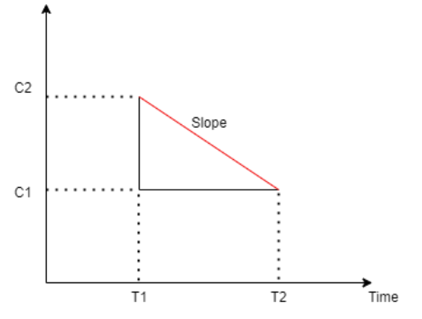

Figure 9 Slope Diagram

The **Figure 9 Slope Diagram** visually represents the relationship between project cost and time for a specific activity. It illustrates how reducing the duration of a task (crashing) increases the associated cost. The diagram typically features a downward-sloping line, where the x-axis represents the time (in weeks or days) and the y-axis represents the cost (in monetary units). The slope of the line indicates the **crash cost per unit time saved**—a steeper slope means higher additional costs for reducing the task duration, while a gentler slope indicates a more cost-effective opportunity for crashing.By using the slope diagram, project managers can easily compare different tasks to determine which ones offer the best trade-off between time savings and cost, ensuring efficient resource allocation and informed decision-making.

## Project crashing diagram

The **network diagram** illustrates the detailed sequence of activities for the **Development of a Smart Home Control Application** project, incorporating the results of the project crashing analysis. Each node in the diagram represents an activity, with the **crashing time** displayed in parentheses next to the activity ID. This approach highlights the reduced durations achieved through crashing, ensuring clarity in understanding the revised project timeline. The arrows connecting the nodes represent the **dependencies between tasks**, ensuring that activities are performed in the correct order to meet project requirements. This structured representation helps project managers and stakeholders visualize the logical flow of activities, making it easier to identify task sequences and potential bottlenecks that may require special attention during execution.

The crashing times displayed in the diagram reflect the optimized durations after applying **crashing strategies**, as outlined in **Table 9 Project Crashing**. Only tasks on the **critical path** have been crashed to achieve meaningful reductions in the overall project duration. Tasks such as **1.5(4)**, **2.3(6)**, and **5.6(4)** are critical activities where reduced durations contribute directly to minimizing the total project timeline. Because any delays in completing these tasks would have a direct effect on the project's overall timeline, they were explicitly designed to crash. Non-critical jobs, on the other hand, continue to take their typical amounts of time because cutting them short would not impact the project's completion date. By concentrating on activities that result in the most time savings, this selective approach to crashing guarantees that resources are distributed effectively.

This diagram provides a clear and structured visualization of how crashing has impacted the project timeline, emphasizing **critical path activities** and their dependencies. By presenting crashing times next to each activity, project managers can easily reference the updated durations and ensure accurate tracking of progress throughout the project lifecycle. Additionally, the diagram aids in identifying the specific points where additional resources were allocated or increased effort was applied to achieve time reductions. The **network diagram** serves as a key tool in project time management, supporting timely project delivery while maintaining control over the additinal costs incurred due to crashing. Moreover, the diagram aids in identifying critical points in the project where additional resources were introduced or where intensified effort was applied to achieve the desired time reductions. It visually highlights the activities most affected by crashing, allowing for better resource planning and real-time decision-making. For example, by examining specific tasks along the critical path, project managers can pinpoint areas where parallel execution or resource reallocation was necessary to mitigate delays. Additionally, it helps the team anticipate possible risks that may arise due to increased pressure on certain tasks and allows for proactive risk mitigation.

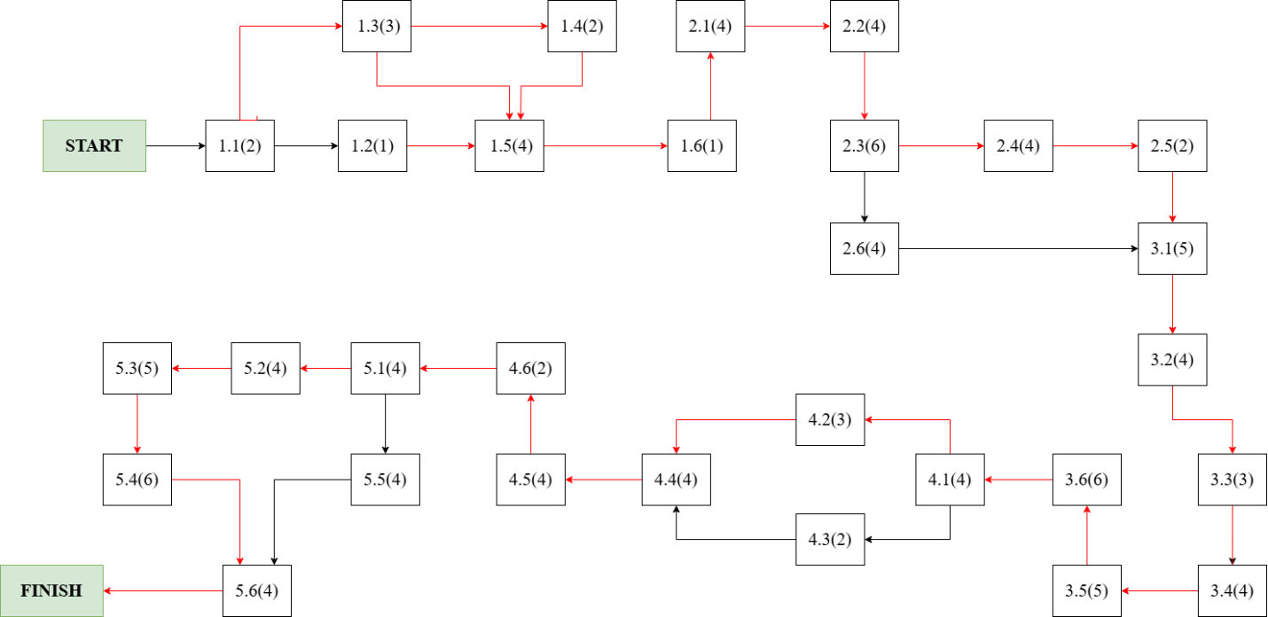

Figure 10 Project Crashing Diagram

The **Figure 10 Project Crashing Diagram** provides a detailed and comprehensive visual representation of the optimized project schedule for the **Development of a Smart Home Control Application**. Each activity in the diagram is displayed with its unique ID, and the crash time is shown in parentheses next to the activity, indicating the reduced duration after applying project crashing. This approach ensures that the overall project timeline is minimized by selectively focusing on critical path activities that directly influence the project’s completion date. The inclusion of crash times in the diagram makes it easier for stakeholders to identify which tasks have been shortened, thereby facilitating improved project control and communication. Task dependencies are shown by the arrows connecting the nodes, which show the order in which tasks must be completed to preserve logical workflow and guarantee efficient execution. The figure highlights the interconnectedness of jobs and graphically depicts the project's complete lifespan, starting at the START node and ending at the FINISH node.

The **critical path**, highlighted in red, plays a pivotal role in determining the overall project duration. Only tasks on the critical path were considered for crashing since they directly affect the project timeline. Reducing the duration of tasks on this path helps to shorten the overall schedule, ensuring that key deadlines are met. For example, tasks like **1.5(4)**, **2.3(6)**, and **5.6(4)** have been crashed, meaning their durations were shortened by allocating additional resources or increasing work intensity. These tasks were prioritized for crashing because any delay in their execution would result in a delay to the entire project. Conversely, tasks not on the critical path, such as **4.3(2)** and **5.5(4)**, were not crashed because reducing their durations would not impact the project’s total duration. This selective approach to crashing ensures an efficient use of resources by focusing on activities that contribute directly to the project timeline, thereby avoiding unnecessary expenses and resource allocation to non-critical tasks.

This network diagram is an essential tool for project managers to monitor and oversee the project's progress since it clearly shows the crashing times next to each activity and highlights the key path. Overall, by offering a clear and organised view of the project's timeline, activities, and dependencies, this optimised network diagram aids in strategic decision-making and makes it easier to deliver the Smart Home Control Application on schedule and within the updated budget and time constraints.

# RISK managemenT

When creating a Smart Home Control Application, risk management is crucial since it guarantees that any risks to the project's success are recognised, examined, and eliminated in a methodical way. By practicing this proactive discipline, stakeholders and project managers may minimise any negative effects on the project's goals by anticipating risks before they materialise. Risk management becomes an essential tool for making sure the project stays on course in the rapidly changing technology world, where smart home solutions must balance innovation, user experience, security, and regulatory compliance. Unexpected difficulties like technological malfunctions, data breaches, or market volatility might jeopardise the effective delivery of sophisticated solutions like a smart home control system if a strong approach to risk identification and management is not taken. Project teams can react quickly and strategically when risks are well managed, which lowers uncertainty and increases confidence in reaching project objectives.

Fundamentally, risk management in this context is methodically identifying potential threats to the smart home system's successful development and implementation. These risks might come from a variety of sources, such as operational, financial, regulatory, and technology aspects. For example, software defects, hardware incompatibilities, or cybersecurity flaws that might jeopardise user data and system integrity are examples of technological hazards. Operational risks may include resource limitations, development process delays, or problems with third-party connections with cloud platforms and smart devices. Financial risks might include budget overruns brought on by unanticipated expenses, while regulatory risks could include breaking industry norms and data protection rules. Instead of trying to completely eliminate all risks, which would be impracticable, the risk management process aims to provide the project team the knowledge and resources they need to make wise choices and put suitable mitigation plans into action.

By fostering a forward-looking and proactive mindset, risk management ensures that potential challenges are addressed early in the project lifecycle. This enables the team to maintain control over key variables, such as time, cost, scope, and quality, while also creating opportunities for continuous improvement. The methodologies and tools employed in risk management may vary depending on the project's specific requirements, but the guiding principles remain the same—identify, assess, prioritize, and respond to risks in a way that supports project success. Whether it's through advanced testing procedures to mitigate software risks, deploying robust encryption and authentication protocols to handle data security risks, or engaging in continuous stakeholder communication to reduce operational uncertainties, risk management plays a crucial role in ensuring that the smart home application meets its objectives. In today's environment, where users demand highly secure and user-friendly solutions, risk management serves not only as a safeguard but also as a strategic enabler, helping the project team navigate complexities and maintain a competitive edge in the market.

**Risk Breakdown Structure** **(RBS)** allows project teams to classify and thoroughly handle any hazards by offering a visible and organised framework for risk management in the Smart Home Control Application project. Technical, operational, financial, and regulatory risks are just a few of the categories into which the RBS hierarchically arranges risks, much like the Work Breakdown Structure (WBS), which breaks down tasks into smaller, more manageable parts. Project managers and stakeholders may systematically assess and rank risks using this granular method, which guarantees that all facets of uncertainty are taken into account. The project team may create focused mitigation plans and concentrate on high-priority risks, including cybersecurity concerns or delays in integrating smart devices, by using the RBS. The visual representation provided by the RBS, as shown in **Figure 11 Risk Breakdown Structure** encourages a culture of readiness and proactive risk management by giving the team the authority to track and control risks throughout the project lifetime. In the end, the RBS is a crucial instrument for guaranteeing that the Smart Home Control Application is delivered with the greatest levels of quality and security, on schedule, and within budget.

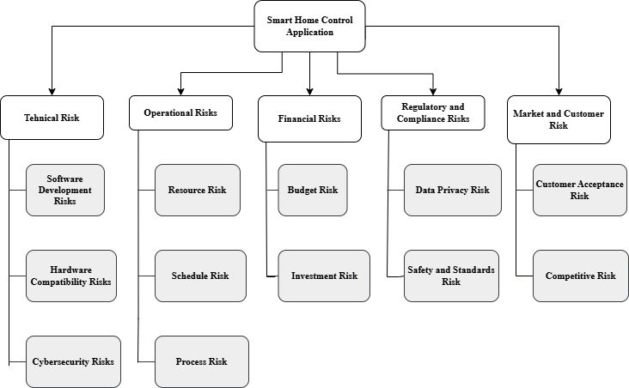

Figure 11 Risk Breakdown Structure

The Risk Breakdown Structure (RBS) depicted in **Figure 11** offers a thorough and organised framework for classifying and detecting any hazards related to the project of developing a smart home control application. The RBS categorises risks into key groups, much like the Work Breakdown Structure (WBS), guaranteeing a methodical approach to risk identification and mitigation across the course of the project. Technical, operational, financial, and regulatory risks are among these categories; each is further subdivided into several subcategories. Technical hazards, for example, include problems with software development, hardware compatibility, and cybersecurity—all important areas that are essential to the smart home system's operation and security. Project managers may concentrate on high-priority risks by using the RBS to break down risks in this systematic way. This helps to ensure that important concerns are resolved before they have an influence on project schedules, quality, or cost.

Operational risks highlighted in the RBS focus on challenges related to resource availability, project scheduling, and dependencies on third-party services or devices. Such risks, if unaddressed, could result in delays in delivering the project milestones or increased operational complexity. Additionally, financial risks include potential budget overruns due to unforeseen costs, fluctuations in resource pricing, or underestimation of required efforts. Regulatory risks, such as non-compliance with data privacy regulations or industry-specific security standards, represent another critical area that could lead to legal issues, reputational damage, or delays. By organizing these risks into a structured hierarchy, the RBS provides clarity and allows project stakeholders to prioritize mitigation efforts efficiently, ensuring that the most significant risks receive adequate attention.

Overall, the RBS in **Figure 11** serves as a critical tool for proactive risk management by enabling continuous monitoring of identified risks and facilitating the identification of new risks as the project evolves. This structured approach ensures that project risks are properly assessed, prioritized, and mitigated in a timely manner, which enhances the overall resilience of the project. Additionally, the visual format of the RBS fosters clearer communication among stakeholders, ensuring that they are well-informed about key risk areas and mitigation strategies being implemented. As a result, the RBS not only helps in minimizing the negative impact of risks but also contributes to the successful and timely delivery of the **Smart Home Control Application** within its defined scope, budget, and schedule. This proactive approach ensures that the project remains on track, fostering stakeholder confidence and enabling the project team to achieve its goals effectively.

## Risk log

A **Table 10 Risk Log** acts as a single repository for recording, tracking, and managing any hazards during the course of a project, making it an essential part of the risk management process. Project managers and other stakeholders may take prompt, appropriate action to reduce possible hazards by using the Risk Log to make sure that all identified risks are methodically recorded, evaluated, and monitored during the development of a smart home control application. This record is essential for controlling any project uncertainties and making sure they don't negatively affect the project's scope, money, or schedule. It offers comprehensive details on every danger, such as the risk's description, classification, possible effects on the project, probability of occurrence, designated risk owner in charge of risk management, and suggested mitigation techniques to address and lessen the risk's possible effects.

The purpose of maintaining a Risk Log goes beyond simply documenting risks; it is designed to enhance visibility and provide a structured approach to handling uncertainties that could negatively impact the project’s objectives. Risks can range from technical issues, such as software malfunctions or hardware compatibility challenges, to external factors, such as changes in regulations or market dynamics. The project team may effectively allocate resources and prioritise remedies to reduce high-priority risks by classifying hazards based on their likelihood and severity. Critical risks—those that represent the biggest danger to the project's successful completion—are handled quickly and efficiently thanks to this prioritisation. Furthermore, the Risk Log guarantees that mitigation measures are actively executed by recording suggested actions and tracking the status of each risk, which lowers the possibility that hazards may materialise or lessens their impact if they do.

By giving stakeholders a clear and up-to-date picture of the project's risk state, the Risk Log not only promotes improved decision-making but also acts as an effective communication tool. Throughout the project lifespan, regular evaluations and updates of the Risk Log assist guarantee that risks are tracked consistently and that mitigation techniques are applicable and efficient. The project team can foresee and prepare for any obstacles thanks to this proactive approach to risk management, which increases the project's overall resilience. Additionally, by showing that risks are being actively managed and mitigated, keeping an updated Risk Log contributes to the development of stakeholder confidence. The Risk Log becomes a vital tool for steering the project towards successful completion by encouraging a culture of accountability and ongoing development. The Risk Log for the Smart Home Control Application is shown in the following table, which includes information on the main risks that were discovered throughout the project, their likelihood, severity, and the steps that were taken to reduce their possible influence on the goals and results.

|  |  |  |  |  |  |  |
| --- | --- | --- | --- | --- | --- | --- |
| **Risk ID** | **Risk Description** | **Category** | **Probability** | **Impact** | **Mitigation Strategy** | **Status** |
| R1 | Third-party smart device integration issues due to protocol inconsistencies | Technical Risks | High | High | Ensure comprehensive validation and certification processes for external devices. | Open |
| R2 | Security issues with smart home systems | Security and Privacy Risks | High | High | Apply strong encryption and enforce stringent access control measures. | Mitigating |
| R3 | UI/UX design delays brought on by a lack of resources | Project Management Risks | Medium | Medium | Strategize resource deployment and maintain a qualified standby team. | Monitoring |
| R4 | Delays in UI/UX design caused by a shortage of resources | Regulatory Risks | Medium | High | Regularly track regulatory changes and maintain compliance. | Open |
| R5 | Problems with hardware compatibility with older devices | Technical Risks | High | High | Perform comprehensive compatibility testing across diverse hardware. | Mitigating |
| R6 | Overspending because of scope creep | Project Management Risks | Medium | High | Enforce strict scope management and perform periodic budget evaluations. | Open |
| R7 | Poor user experience leading to low user uptake | Market Risks | Low | Medium | Improve user experience by leveraging ongoing feedback and iterative enhancements. | Monitoring |
| R8 | Dependency on vendors for cloud services | Operational Risks | Medium | High | Create backup plans and secure relationships with alternative suppliers. | Mitigating |

Table 10 Risk Log

The **Risk Log**, as presented in **Table 10**, is an essential tool for managing the identified risks throughout the lifecycle of the Development of a Smart Home Control Application project. The log systematically records key details about each risk, including a unique identifier (Risk ID), a clear description, the category under which the risk falls, the likelihood of its occurrence, the potential impact it could have on the project, the mitigation strategy devised, and the current status of the risk. This structured approach ensures that risks are monitored effectively, and mitigation efforts are continuously tracked to minimize any adverse effects on project deliverables, timelines, or budgets.

Each **Risk Description** in the table provides a concise yet comprehensive summary of the potential issue. For example, risks such as **R1: Difficulty integrating third-party smart devices due to protocol and API inconsistencies. R5: Compatibility issues with legacy devices stemming from outdated hardware standards.**are technical in nature and could severely impact the project’s technical stability and functionality if not addressed. The categories assigned to each risk—such as **Technical Risks**, **Security and Privacy Risks**, **Project Management Risks**, **Regulatory Risks**, and **Operational Risks**—help in organizing risks based on their nature and origin, making it easier for project managers to prioritize them effectively.

The columns for **Likelihood** and **Impact** play a pivotal role in prioritizing risks. Likelihood measures the probability of a specific risk occurring, while impact gauges the potential severity of the damage or disruption it could cause if it materializes.

For instance, risks such as **R2** (cybersecurity vulnerabilities) and **R6** (budget overruns due to scope creep) are both rated as high in terms of likelihood and impact, indicating that these are high-priority risks requiring immediate and sustained attention. On the other hand, risks with lower likelihood, such as **R7** (low user adoption due to poor user experience), are monitored regularly but may not demand urgent mitigation unless circumstances change.

The **Mitigation Strategy** column outlines specific actions that can be taken to reduce the likelihood or impact of each risk. Strategies range from conducting thorough compatibility testing (to address risks related to third-party device integration and hardware compatibility) to implementing robust encryption protocols (to mitigate cybersecurity threats). These strategies are essential in transforming potential risks into manageable challenges, ensuring that the project remains resilient against uncertainties.

Lastly, the **Status** column indicates the current state of each risk. Risks marked as **Open** are actively being monitored and require ongoing attention, while those marked as **Mitigating** have mitigation strategies in place that are being executed to minimize their impact. Risks in the **Monitoring** phase are under observation, with contingency plans ready to be deployed if necessary.

Overall, **Table 10 Risk Log** is not merely a passive record of potential problems but an active tool for fostering a proactive risk management culture within the project team. By maintaining and regularly updating the Risk Log, project managers ensure that all team members and stakeholders remain vigilant, prepared, and aligned in their efforts to address emerging threats. Furthermore, the log serves as a transparent communication tool that enhances stakeholder confidence by demonstrating that risks are being systematically identified, assessed, and controlled.

This robust and dynamic risk management approach is crucial for ensuring the successful completion of the Smart Home Control Application project, particularly in a highly dynamic and competitive technological environment where unforeseen challenges are commonplace. Proper risk management minimizes disruptions, optimizes resource utilization, and ultimately enhances the likelihood of delivering a high-quality application on time and within budget.

## Probability/Impact Matrix for Negative Risks

Project management is inherently uncertain, and project outcomes are greatly influenced by the capacity to effectively manage risks. A useful tool for classifying possible hazards by evaluating their chance and impact size is the Probability/Impact (P/I) Matrix. By using this matrix, the Smart Home Control Application project can be executed more smoothly by ensuring that important risks are identified early on and dealt with in a timely and efficient manner.

The project team may then concentrate on the risks that are most likely to jeopardise the project's development and results.High probability-high impact, high probability-low impact, low probability-high impact, and low probability-low impact are the four separate quadrants into which the matrix is divided. Risks that fall into the high probability-high impact quadrant require quick attention because, if left unchecked, they might seriously impede project progress or drive up expenses. Conversely, hazards that are less likely to occur and have a smaller impact need less attention right away, but they should still be examined on a regular basis to avoid unanticipated problems. The most important hazards are addressed first because to the efficient prioritisation made possible by this hierarchical categorisation.

By utilizing the Probability/Impact Matrix, the project team gains a clearer perspective on which uncertainties could have the greatest influence on the project's schedule, budget, and deliverables. The matrix also supports proactive risk mitigation by providing a visual overview of all identified risks, making it easier for stakeholders to understand the potential challenges ahead. The following figure presents the matrix, showing a breakdown of risks specific to the **Smart Home Control Application** project, with each risk plotted according to its estimated probability and potential impact.

Figure 12 Impact/Probability Negative Matrix

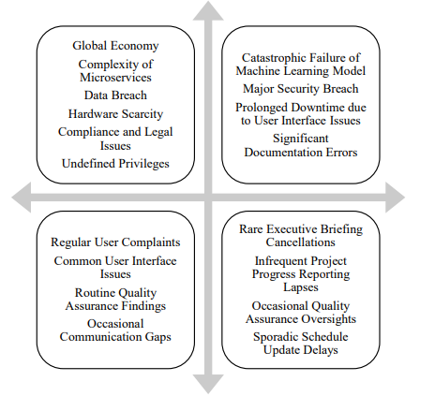

significant data leak   
Penalties under the law   
Complete system failure   
Extreme overspending on the budget

Third-party integration issues

Cybersecurity threats

Cloud service downtime

Data privacy violations

Major system failure

Small UI issues

Lags in performance

Warnings about device compatibility

User complaints from time to time

Gaps in team communication

Delays in reporting

Mistakes in the documentation

Low adoption of features

The **Figure 12 Impact/Probability Negative Matrix** is an essential part of risk management; it gives the project team the opportunity to graphically evaluate and rank risks based on their likelihood of happening and their influence on project objectives. Risks including cloud service failures, cybersecurity flaws, and difficulties integrating with third parties are shown in the picture as being in the high probability-high impact quadrant, indicating the necessity of quick and focused mitigation measures. The functionality, security, and general user experience of the system are seriously threatened by these risks, thus timely and efficient management is crucial to the development and successful implementation of the smart home control application.

On the other hand, the high probability-low impact quadrant (see the top left quadrant in the diagram) contains hazards such as small UI problems and performance delays, which are common but do not represent serious threats to the project's overall success. Regular upgrades and quality assurance procedures can mitigate these risks without requiring a large reallocation of resources. Similar to this, hazards in the low probability-high impact quadrant—like significant data breaches or legal penalties—are less likely to happen but, if they do, might have disastrous results. Therefore, even if they happen less frequently, they still need to be properly watched, and precautions like strict security procedures and compliance audits should be put in place.

Lastly, risks with both low probability and low impact, such as **team communication gaps** and **reporting delays**, pose minimal threat to the project’s success (refer to bottom left quadrant in the figure). These risks can generally be handled through routine project management practices, such as regular status meetings and clear communication protocols. Overall, by categorizing risks using the Probability/Impact Matrix, the project team can ensure a well-balanced approach to risk mitigation, focusing on the most critical threats while maintaining a proactive stance on lower-priority risks. This systematic approach helps enhance project resilience, ensuring smooth progress toward the successful delivery of the **Smart Home Control Application**.

## Probability/Impact Matrix for Positive Risks

In project management, recognizing and capitalizing on positive risks, often termed opportunities, is as crucial as mitigating negative risks. The Probability/Impact Matrix for Positive Risks is an essential analytical framework that enables project teams to identify and prioritize potential opportunities based on their likelihood of occurrence and the value they can deliver. For the Smart Home Control Application project, such opportunities, if effectively leveraged, could result in enhanced features, expedited timelines, reduced expenditure, or greater user satisfaction.

This matrix segments opportunities into four distinct quadrants, helping the project team differentiate between those that demand immediate action and those that warrant a more measured approach. High-probability, high-impact opportunities, such as forging advantageous partnerships or early adoption of cutting-edge technology, are critical and should be pursued without delay to maximize project gains. Conversely, opportunities with a lower probability but significant impact, such as favorable changes in regulations, may require vigilant observation and adaptable resource allocation to seize when the conditions are right.

By employing the Probability/Impact Matrix for Positive Risks, the project team can proactively harness opportunities that contribute to project excellence. This systematic approach facilitates well-informed decision-making and ensures that key opportunities are identified and acted upon.

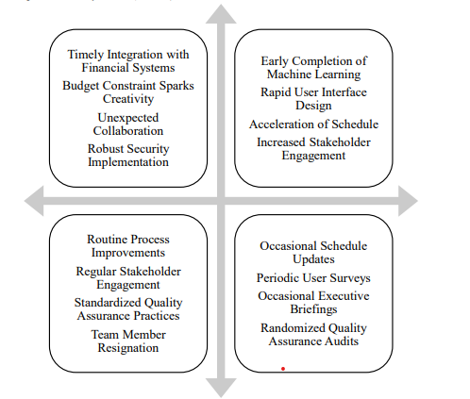

Strategic partnerships with major smart device manufacturers

Breakthrough in energy-efficient smart systems

Major cost reduction in hardware components

Regulatory incentives for technology adoption

Minor cost savings from unexpected sources

Improvements in operational efficiency

Unforeseen small-scale collaborations

Incremental gains from ongoing innovation efforts

Early completion of development phases

Rapid user adoption

Accelerated integration with smart devices

Positive media coverage

Routine user feedback leading to small improvements

Minor process optimizations

Increased engagement from early adopters

Positive peer reviews

Figure 13 Probability/Impact Matrix for Positive Risks

The **Probability/Impact Matrix for Positive Risks**, as shown in **Figure 13**, provides a systematic way to categorize and prioritize opportunities that can significantly benefit the project. High probability-high impact opportunities, such as early **completion of development phases**, **rapid user adoption**, and **accelerated integration with smart devices**, are stored in the top-right quadrant of the matrix. These opportunities, if pursued effectively, can lead to faster project delivery, enhanced user satisfaction, and better market positioning of the smart home control application. To capitalize on these opportunities, the project team should focus on optimizing workflows and actively engaging stakeholders for faster adoption.

Otherwise, high probability-low impact opportunities, such as **routine user feedback leading to small improvements** and **minor process optimizations**, are positioned in the top-left quadrant of the matrix. These opportunities are frequent but offer only incremental benefits. However, by consistently implementing these minor enhancements (refer to top-left quadrant in **Figure 13**), the project team can ensure continuous improvement in the product’s functionality and user experience without significant resource allocation.

In the bottom-right quadrant, low probability-high impact opportunities, such as collaborative alliances **breakthroughs in energy-efficient systems**, and **regulatory incentives**, represent rare but highly valuable opportunities. These opportunities, though less likely to occur, can yield significant advantages for the project, including cost reductions and increased market competitiveness. Lastly, low probability-low impact opportunities, like **minor cost savings from unexpected sources** and **improvements in operational efficiency**, are placed in the bottom-left quadrant of the matrix. While these have minimal impact, they still contribute positively to the project’s overall performance when realized. By leveraging this matrix, the project team ensures that no opportunity is overlooked and that resources are focused on the most valuable prospects.

# REFERENCES

1. Kerzner, H., "Project Management: A Systems Approach to Planning, Scheduling, and Controlling," 7th ed., Wiley, 2013.
2. Project Management Institute (PMI), "A Guide to the Project Management Body of Knowledge (PMBOK Guide)," 7th ed., Project Management Institute, 2021.
3. Sommerville, I., "Software Engineering," 10th ed., Pearson, 2015.
4. Wideman, R. M., "Project and Program Risk Management: A Guide to Managing Project Risks and Opportunities," Project Management Institute, 1992.
5. ISO/IEC 12207:2017, "Systems and Software Engineering - Software Life Cycle Processes," International Organization for Standardization, 2017.
6. IEEE Std 830-1998, "IEEE Recommended Practice for Software Requirements Specifications," IEEE, 1998.
7. "Smart Home Trends and IoT Integration," IoT Analytics Research, 2023, available at [<https://www.iot-analytics.com>].
8. Microsoft, "Microsoft Project Official Documentation," Microsoft, available at [<https://learn.microsoft.com/en-us/project>].
9. AWS Cloud Services, "AWS IoT Core: Enabling Smart Home Applications," Amazon Web Services, available at [<https://aws.amazon.com/iot-core/>].